UNITED STATES
SECURITIES AND EXCHANGE COMMISSION

Washington, D.C. 20549
________________________________
FORM 8-K
________________________________
CURRENT REPORT

Pursuant to Section 13 or 15(d) of the
Securities Exchange Act of 1934

Date of Report (Date of Earliest Event Reported): July 29, 2026
PROG HOLDINGS, INC.
(Exact name of Registrant as Specified in Charter)
Georgia |  |  |  |  |  | 1-39628 |  |  |  |  |  | 85-2484385
(State or other Jurisdiction of Incorporation) |  |  |  |  |  | (Commission File  Number) |  |  |  |  |  | (IRS Employer  Identification No.)
256 W. Data Drive |  |  |  |  |  | Draper, |  |  | Utah |  |  |  |  |  | 84020-2315
(Address of principal executive offices) |  |  |  |  |  |  |  |  |  |  |  |  |  |  | (Zip Code)
Registrant’s telephone number, including area code: (385) 351-1369
Not Applicable
(Former Name or Former Address, if Changed Since Last Report)
Check the appropriate box below if the Form 8-K filing is intended to simultaneously satisfy the filing obligation of the registrant under any of the following provisions (see General Instruction A.2. below):
☐ Written communications pursuant to Rule 425 under the Securities Act (17 CFR 230.425)
☐ Soliciting material pursuant to Rule 14a-12 under the Exchange Act (17 CFR 240.14a-12)
☐ Pre-commencement communications pursuant to Rule 14d-2(b) under the Exchange Act (17 CFR 240.14d-2(b))
☐ Pre-commencement communications pursuant to Rule 13e-4(c) under the Exchange Act (17 CFR 240.13e-4(c))
Securities registered pursuant to Section 12(b) of the Act:
Title of each class |  |  | Trading Symbol |  |  | Name of each exchange on which registered
Common Stock, $0.50 Par Value |  |  | PRG |  |  | New York Stock Exchange
Indicate by check mark whether the registrant is an emerging growth company as defined in Rule 405 of the Securities Act of 1933 (§230.405 of this chapter) or Rule 12b-2 of the Securities Exchange Act of 1934 (§240.12b-2 of this chapter).
Emerging growth company ☐
If an emerging growth company, indicate by check mark if the registrant has elected not to use the extended transition period for complying with any new or revised financial accounting standards provided pursuant to Section 13(a) of the Exchange Act. ☐

ITEM 2.02. RESULTS OF OPERATIONS AND FINANCIAL CONDITION
On July 29, 2026, PROG Holdings, Inc. (the "Company") issued a press release (the "Press Release") announcing its financial results for the second quarter ended June 30, 2026. A copy of the Press Release is furnished herewith as Exhibit 99.1 and is incorporated herein by reference. The information contained in this paragraph, as well as Exhibit 99.1 referenced herein, shall not be deemed "filed" for purposes of Section 18 of the Securities Exchange Act of 1934, nor shall it be deemed incorporated by reference in any filing under the Securities Act of 1933.

ITEM 8.01. OTHER EVENTS

On July 29, 2026, the Company announced with deep sadness that Douglas C. Curling, a member of the Company’s Board of Directors (the “Board”), passed away unexpectedly on July 25, 2026.

In light of Mr. Curling’s passing, on July 27, 2026, the Board reduced the size of the Board from ten members to nine members, effective immediately.

The Board, management team, and employees of the Company extend their deepest condolences to Mr. Curling’s family and express profound gratitude for his leadership and more than a decade of dedicated service to the Company.

ITEM 9.01. FINANCIAL STATEMENTS AND EXHIBITS

(d) Exhibits:

Exhibit No. |  |  | Description
99.1 |  |  | Press release, dated July 29, 2026.
99.2 |  |  | PROG Holdings, Inc. Earnings Supplement Presentation, dated July 29, 2026.
104 |  |  | The cover page from this Current Report on Form 8-K, formatted in Inline XBRL

SIGNATURES

Pursuant to the requirements of the Securities Exchange Act of 1934, the registrant has duly caused this report to be signed on its behalf by the undersigned hereunto duly authorized.

 |  |  |  |  |  |  |  |  | PROG Holdings, Inc.
 |  |  |  |  |  | By: |  |  | /s/ Brian Garner
Date: |  |  | July 29, 2026 |  |  |  |  |  | Brian Garner  Chief Financial Officer

Exhibit 99.1

PROG Holdings Reports Second Quarter 2026 Results
•Consolidated revenues from continuing operations of $719.7 million, up 22.3%; Net earnings from continuing operations of $37.4 million
•Adjusted EBITDA from continuing operations of $88.4 million, up 22.8%
•Diluted EPS from continuing operations of $0.92; Non-GAAP Diluted EPS from continuing operations of $1.19, up 19.0%
•Consolidated GMV of $902.0 million, up 60.1%
•Net leverage ratio ended the quarter at 1.7x

SALT LAKE CITY, July 29, 2026 - PROG Holdings, Inc. (NYSE:PRG), the fintech holding company for Progressive Leasing, Four Technologies, MoneyApp and Purchasing Power, today announced financial results for the second quarter ended June 30, 2026, which includes the results of Purchasing Power since January 2, 2026, the date the Company acquired Purchasing Power.
"PROG Holdings delivered a strong second quarter, with revenue toward the higher end of our outlook and both adjusted EBITDA and Non-GAAP EPS coming in above the top end of our April outlook ranges, a reflection of disciplined execution across the business," said PROG Holdings Chairman, President and CEO Steve Michaels. "Every product in our ecosystem contributed: consolidated GMV grew 60% year-over-year, Progressive Leasing returned to positive GMV growth of 3.4% with adjusted EBITDA margin at 12.7%, Four delivered its eleventh consecutive quarter of triple-digit GMV growth, and Purchasing Power's GMV grew double-digits."
"Equally important was our continued strengthening of the balance sheet. We used our strong cash flow to pay down debt, bringing our net leverage ratio to approximately 1.7 times, down from about 2.5 times right after the acquisition of Purchasing Power, and comfortably within our targeted range of 1.5 to 2.0 times. This deleveraging gave us the confidence to resume share repurchases during the quarter."
"Reflecting our second-quarter outperformance and the momentum we see across our product ecosystem, we are raising our full-year 2026 outlook. Our performance is a testament to the resilience of our platform and the discipline with which we run it," concluded Michaels.

Consolidated Results
Consolidated revenues for the second quarter of 2026 were $719.7 million, an increase of 22.3% from the same period in 2025.
Consolidated net earnings from continuing operations for the quarter were $37.4 million, compared with $37.6 million in the prior year period. The effective income tax rate was 26.4% in the second quarter of 2026, compared to 26.5% in the same period in the prior year. Adjusted EBITDA from continuing operations for the quarter was $88.4 million, or 12.3% of revenues, compared with $72.0 million, or 12.2% of revenues for the same period in 2025.
Diluted earnings per share from continuing operations for the second quarter of 2026 were $0.92, compared with $0.93 in the year ago period. On a non-GAAP basis, diluted earnings per share from continuing operations were up 19.0% at $1.19 in the second quarter of 2026, compared with $1.00 for the same period in 2025.
Progressive Leasing Results
Progressive Leasing's second quarter GMV of $428.1 million was up 3.4% compared to the same period in 2025. Revenues were $550.6 million, down 3.4% from the prior year. The provision for lease merchandise write-offs for the quarter was 8.4% of leasing revenues. Earnings before taxes for the second quarter of 2026 were $45.4 million, down 11.9% from the second quarter of 2025. Adjusted EBITDA was $69.9 million, up 0.3% from the second quarter of 2025.
Four Results
Four's GMV for the second quarter of 2026 was $315.1 million, an increase of 110.6% compared to the same period in the prior year. Revenues were $35.1 million, up 118.2% from the year ago period. Four's earnings before taxes for the second quarter of 2026 were $7.1 million, up 139.9% from the second quarter of 2025. Adjusted EBITDA was $8.7 million, up 111.2% from the second quarter of 2025.
Purchasing Power Results
The Company acquired Purchasing Power on January 2, 2026. Purchasing Power's GMV, which is defined as the total value of merchandise and services purchased and delivered to customers through its platform, was $158.8 million, up 15.2% from the second quarter of 2025 on a standalone basis.

Revenues were $130.4 million in the second quarter of 2026. Loss before taxes was $0.3 million and adjusted EBITDA was $10.6 million for the second quarter of 2026.

Liquidity and Capital Allocation
PROG Holdings ended the second quarter of 2026 with cash of $85.2 million and gross debt of $893.7 million. During the quarter, the Company repaid $50.0 million of debt related to the acquisition of Purchasing Power. Since the acquisition of Purchasing Power, the Company has reduced its total debt by $304.9 million. The Company repurchased $10.2 million of its stock in the quarter at an average price of $36.37 per share, leaving $299.4 million of repurchase capacity under its $500 million share repurchase program. Additionally, the Company paid a quarterly cash dividend of $0.14 per share.

2026 Outlook
Due to the strong start to the year and the momentum in the business, the Company is increasing its full year 2026 outlook for revenue and earnings as well as providing guidance for the third quarter of 2026. This outlook assumes an operating environment with no change in the current financial pressures and uncertainties for our customers, no material changes in the Company's decisioning posture, no meaningful increase in unemployment rates for our consumer base, an effective tax rate for non-GAAP EPS of approximately 26% and no impact from additional share purchases.

 |  |  | Revised 2026 outlook |  |  |  |  |  |  |  |  | Previous 2026 outlook
(In thousands, except per share amounts) |  |  | Low |  |  | High |  |  |  |  |  | Low |  |  | High
PROG Holdings - Total revenues from continuing operations |  |  | $ | 3,025,000 |  | $ | 3,100,000 |  |  |  |  | $ | 3,000,000 |  | $ | 3,100,000
PROG Holdings - Net earnings from continuing operations |  |  | 155,000 |  |  | 164,500 |  |  |  |  |  | 150,500 |  |  | 166,000
PROG Holdings - Adjusted EBITDA from continuing operations |  |  | 355,000 |  |  | 375,000 |  |  |  |  |  | 343,000 |  |  | 370,000
PROG Holdings - Diluted EPS from continuing operations |  |  | 3.82 |  |  | 4.06 |  |  |  |  |  | 3.68 |  |  | 4.06
PROG Holdings - Diluted non-GAAP EPS from continuing operations |  |  | 4.75 |  |  | 5.00 |  |  |  |  |  | 4.40 |  |  | 4.80
Progressive Leasing - Total revenues |  |  | 2,247,500 |  |  | 2,285,000 |  |  |  |  |  | 2,227,500 |  |  | 2,285,000
Progressive Leasing - Earnings before taxes |  |  | 188,500 |  |  | 193,000 |  |  |  |  |  | 191,000 |  |  | 198,500
Progressive Leasing - Adjusted EBITDA |  |  | 272,500 |  |  | 279,500 |  |  |  |  |  | 269,500 |  |  | 279,500
Purchasing Power - Total revenues |  |  | 620,000 |  |  | 640,000 |  |  |  |  |  | 620,000 |  |  | 640,000
Purchasing Power - Earnings before taxes |  |  | 17,000 |  |  | 21,500 |  |  |  |  |  | 14,500 |  |  | 22,000
Purchasing Power - Adjusted EBITDA |  |  | 54,000 |  |  | 60,000 |  |  |  |  |  | 50,000 |  |  | 60,000
Four - Total revenues |  |  | 145,000 |  |  | 157,000 |  |  |  |  |  | 140,000 |  |  | 157,000
Four - Earnings before taxes |  |  | 22,000 |  |  | 25,000 |  |  |  |  |  | 16,500 |  |  | 20,500
Four - Adjusted EBITDA |  |  | 30,000 |  |  | 34,000 |  |  |  |  |  | 25,000 |  |  | 29,000
Other - Total revenues |  |  | 12,500 |  |  | 18,000 |  |  |  |  |  | 12,500 |  |  | 18,000
Other - Loss before taxes |  |  | (13,500) |  |  | (10,500) |  |  |  |  |  | (14,500) |  |  | (12,000)
Other - Adjusted EBITDA |  |  | (1,500) |  |  | 1,500 |  |  |  |  |  | (1,500) |  |  | 1,500
Three months ended
September 30, 2026 outlook
(In thousands, except per share amounts) |  |  |  |  |  | Low |  |  | High
PROG Holdings - Total revenues from continuing operations |  |  |  |  |  | $ | 715,000 |  | $ | 750,000
PROG Holdings - Net earnings from continuing operations |  |  |  |  |  | 36,000 |  |  | 42,500
PROG Holdings - Adjusted EBITDA from continuing operations |  |  |  |  |  | 79,000 |  |  | 89,000
PROG Holdings - Diluted EPS from continuing operations |  |  |  |  |  | 0.86 |  |  | 1.06
PROG Holdings - Diluted non-GAAP EPS from continuing operations |  |  |  |  |  | 1.00 |  |  | 1.20

Conference Call and Webcast
The Company has scheduled a live webcast and conference call for Wednesday, July 29, 2026, at 8:30 A.M. ET to discuss its financial results for the second quarter of 2026. To access the live webcast, visit the Events and Presentations page of the Company’s Investor Relations website, https://investor.progholdings.com/.
About PROG Holdings, Inc.
PROG Holdings, Inc. (NYSE:PRG) is a fintech holding company headquartered in Salt Lake City, UT, that provides inclusive, transparent and competitive payment options to consumers. The Company owns Progressive Leasing, a leading provider of e-commerce, app-based, and in-store point-of-sale lease-to-own solutions; Purchasing Power, a voluntary employee benefit program provider, allowing employees to purchase brand-name products and services through either automatic payroll deductions or allotments; Four Technologies, a provider of Buy Now, Pay Later payment options through its platform, Four; and MoneyApp, a mobile application that offers customers interest-free cash advances. More information on PROG Holdings and its companies can be found at https://investor.progholdings.com/.
Forward-Looking Statements:
Statements, estimates and projections in this press release regarding our business that are not historical facts are "forward-looking statements" that involve risks and uncertainties which could cause actual results to differ materially from those contained in the forward-looking statements. Such forward-looking statements generally can be identified by the use of forward-looking terminology, such as "continued," "targeted," and "outlook," and similar forward-looking terminology. These risks and uncertainties include (i) continued volatility and challenges in the macroeconomic environment, including due to the war in Iran and related geopolitical disruptions and increases in fuel and other prices, and their impact on: (a) consumer confidence and customer demand for the merchandise that our retail partners and Purchasing Power sell, in particular consumer durables, such as home appliances, electronics and furniture; (b) our customers’ disposable income and their ability to make the lease and loan payments they owe the Company; and (c) our overall financial performance and outlook; (ii) the impact of the uncertain macroeconomic environment on our proprietary algorithms and decisioning tools that we use to approve customers such that they are no longer indicative of our customers’ ability to perform, which in turn may limit the ability of our businesses to manage risk, avoid lease and loan charge-offs and may result in insufficient reserves to cover actual losses; (iii) a large percentage of Progressive Leasing's revenue being concentrated with several key retail partners, and the loss of any of these retail partner relationships materially and adversely affecting several aspects of our performance; (iv) Progressive Leasing being unable to attract additional retail partners and retain and grow its relationships with its existing retail partners, and/or Purchasing Power being unable to attract additional employer-clients and retain and grow its relationships with its existing clients, resulting in several aspects of our performance being materially and adversely affected; (v) our businesses being unable to attract new consumers and retain and grow their relationships with their existing customers materially and adversely affecting several aspects of our performance; (vi) Four’s and Purchasing Power's business models differing significantly from Progressive Leasing’s lease-to-own business, which

means these businesses have different risk profiles; (vii) our efforts to modernize and enhance certain enterprise-wide information management systems and technologies adversely impacting our businesses and operations; (viii) the inability of our businesses to successfully operate in highly and increasingly competitive industries materially and adversely affecting several aspects of our performance; (ix) our business, results of operations, financial condition, and prospects being materially and adversely affected due to our businesses failing to maintain a consistently high level of consumer satisfaction and trust in its brands; (x) our businesses being subject to extensive federal, state and local laws and regulations, including certain laws and regulations unique to the industries in which our businesses operate, that may subject them to government investigations and significant monetary penalties, remediation expenses and compliance-related burdens that may result in them changing the manner in which they operate, which may be materially adverse to several aspects of our performance; (xi) our performance being materially and adversely affected due to the transactions offered to consumers by our businesses being negatively characterized by federal, state and local government officials, consumer advocacy groups and the media; (xii) our inability to protect confidential, proprietary, or sensitive information, including the confidential information of our customers, being adversely affected by cyber-attacks or similar disruptions, which may result in significant costs, litigation and reputational damage or otherwise have a material adverse impact on several aspects of our performance; (xiii) any significant disruption in our vendors' information technology systems, or disruptions in the information our businesses rely on in their lease and loan decisioning, materially and adversely affecting several aspects of our performance; (xiv) our capital allocation strategy and financial policies; and (xv) the other risks and uncertainties discussed under "Risk Factors" in the Company’s Annual Report on Form 10-K for the fiscal year ended December 31, 2025, filed with the SEC on February 18, 2026. Statements, estimates and projections in this press release that are "forward-looking" include without limitation statements, estimates and projections about: (i) the strength of our balance sheet; (ii) our net leverage ratio; and (iii) our revised full year 2026 outlook and the guidance we provide for the third quarter of 2026. You are cautioned not to place undue reliance on these forward-looking statements, which speak only as of the date of this press release. Except as required by law, the Company undertakes no obligation to update these forward-looking statements to reflect subsequent events or circumstances after the date of this press release.
Investor Contact
John A. Baugh, CFA
Vice President, Investor Relations
john.baugh@progholdings.com

PROG Holdings, Inc.

Consolidated Statement of Earnings
(In thousands, except per share data)
 |  |  | (Unaudited)  Three months ended |  |  |  |  |  |  |  |  |  |  |  | (Unaudited)  Six months ended
 |  |  | June 30, |  |  |  |  |  |  |  |  |  |  |  | June 30,
 |  |  | 2026 |  |  |  |  |  | 2025 |  |  |  |  |  | 2026 |  |  |  |  |  | 2025
Revenues
Lease revenues and fees |  |  | $ | 549,830 |  |  |  |  | $ | 569,674 |  |  |  |  | $ | 1,146,694 |  |  |  |  | $ | 1,221,231
Product and service revenues |  |  | 128,507 |  |  |  |  |  | — |  |  |  |  |  | 234,913 |  |  |  |  |  | —
Other revenue |  |  | 41,378 |  |  |  |  |  | 18,829 |  |  |  |  |  | 80,782 |  |  |  |  |  | 35,700
 |  |  | 719,715 |  |  |  |  |  | 588,503 |  |  |  |  |  | 1,462,389 |  |  |  |  |  | 1,256,931
Costs and expenses
Depreciation of lease merchandise |  |  | 364,311 |  |  |  |  |  | 385,107 |  |  |  |  |  | 773,321 |  |  |  |  |  | 845,550
Cost of product sales |  |  | 75,702 |  |  |  |  |  | — |  |  |  |  |  | 138,208 |  |  |  |  |  | —
Provision for lease merchandise write-offs |  |  | 46,499 |  |  |  |  |  | 42,633 |  |  |  |  |  | 90,150 |  |  |  |  |  | 90,651
Operating expenses |  |  | 143,417 |  |  |  |  |  | 93,409 |  |  |  |  |  | 293,617 |  |  |  |  |  | 191,533
Provision for credit losses |  |  | 30,667 |  |  |  |  |  | 8,043 |  |  |  |  |  | 54,834 |  |  |  |  |  | 13,544
 |  |  | 660,596 |  |  |  |  |  | 529,192 |  |  |  |  |  | 1,350,130 |  |  |  |  |  | 1,141,278
Gain on sale of lease receivables |  |  | 4,701 |  |  |  |  |  | — |  |  |  |  |  | 11,158 |  |  |  |  |  | —
Gain on change in fair value of receivables |  |  | 1,810 |  |  |  |  |  | — |  |  |  |  |  | 7,522 |  |  |  |  |  | —
Operating profit |  |  | 65,630 |  |  |  |  |  | 59,311 |  |  |  |  |  | 130,939 |  |  |  |  |  | 115,653
Interest expense |  |  | (15,217) |  |  |  |  |  | (9,794) |  |  |  |  |  | (33,606) |  |  |  |  |  | (19,757)
Interest income |  |  | 394 |  |  |  |  |  | 1,645 |  |  |  |  |  | 1,037 |  |  |  |  |  | 2,518
Earnings from continuing operations before income tax expense |  |  | 50,807 |  |  |  |  |  | 51,162 |  |  |  |  |  | 98,370 |  |  |  |  |  | 98,414
Income tax expense |  |  | 13,429 |  |  |  |  |  | 13,581 |  |  |  |  |  | 24,774 |  |  |  |  |  | 26,243
Net earnings from continuing operations |  |  | 37,378 |  |  |  |  |  | 37,581 |  |  |  |  |  | 73,596 |  |  |  |  |  | 72,171
(Loss) earnings from discontinued operations, net of tax |  |  | (349) |  |  |  |  |  | 902 |  |  |  |  |  | (513) |  |  |  |  |  | 1,030
Net earnings |  |  | $ | 37,029 |  |  |  |  | $ | 38,483 |  |  |  |  | $ | 73,083 |  |  |  |  | $ | 73,201
Basic earnings per share
Continuing operations |  |  | $ | 0.93 |  |  |  |  | $ | 0.94 |  |  |  |  | $ | 1.84 |  |  |  |  | $ | 1.78
Discontinued operations |  |  | (0.01) |  |  |  |  |  | 0.02 |  |  |  |  |  | (0.01) |  |  |  |  |  | 0.03
Total basic earnings per share |  |  | $ | 0.92 |  |  |  |  | $ | 0.96 |  |  |  |  | $ | 1.83 |  |  |  |  | $ | 1.81
Diluted earnings per share
Continuing operations |  |  | $ | 0.92 |  |  |  |  | $ | 0.93 |  |  |  |  | $ | 1.81 |  |  |  |  | $ | 1.75
Discontinued operations |  |  | (0.01) |  |  |  |  |  | 0.02 |  |  |  |  |  | (0.01) |  |  |  |  |  | 0.03
Total diluted earnings per share |  |  | $ | 0.91 |  |  |  |  | $ | 0.95 |  |  |  |  | $ | 1.80 |  |  |  |  | $ | 1.78
Cash dividend declared per share
Common stock |  |  | $ | 0.14 |  |  |  |  | $ | 0.13 |  |  |  |  | $ | 0.28 |  |  |  |  | $ | 0.26
Weighted average shares outstanding
Basic |  |  | 40,177 |  |  |  |  |  | 40,130 |  |  |  |  |  | 40,038 |  |  |  |  |  | 40,484
Diluted |  |  | 40,734 |  |  |  |  |  | 40,559 |  |  |  |  |  | 40,772 |  |  |  |  |  | 41,203

PROG Holdings, Inc.

Consolidated Balance Sheets
(In thousands, except share data)

 |  |  |  |  |  | (Unaudited)
 |  |  |  |  |  | June 30,  2026 |  |  |  |  |  | December 31,  2025
Assets
Cash and cash equivalents |  |  |  |  |  | $ | 85,201 |  |  |  |  | $ | 308,774
Restricted cash |  |  |  |  |  | 7,168 |  |  |  |  |  | —
Receivables (net of allowances and unearned interest income of $94,401 in 2026 and $68,806 in 2025; includes $106,069 recorded at fair value in 2026)1 |  |  |  |  |  | 374,522 |  |  |  |  |  | 74,228
Other receivables (net of allowances and unearned interest income of $7,137 in 2026 and $— in 2025; includes $10,063 recorded at fair value in 2026)1 |  |  |  |  |  | 39,777 |  |  |  |  |  | —
Lease merchandise (net of accumulated depreciation and allowances of $429,925 in 2026 and $407,104 in 2025) |  |  |  |  |  | 531,071 |  |  |  |  |  | 609,009
Loans receivable (net of allowances and unamortized fees of $19,808 in 2026 and $18,246 in 2025) |  |  |  |  |  | 74,312 |  |  |  |  |  | 90,648
Property and equipment, net |  |  |  |  |  | 24,414 |  |  |  |  |  | 19,526
Goodwill and other intangibles, net |  |  |  |  |  | 763,089 |  |  |  |  |  | 353,835
Income tax receivable |  |  |  |  |  | 25,150 |  |  |  |  |  | 47,894
Deferred income tax assets |  |  |  |  |  | 18,852 |  |  |  |  |  | 19,561
Prepaid expenses and other assets |  |  |  |  |  | 93,827 |  |  |  |  |  | 73,383
Assets of discontinued operations |  |  |  |  |  | 10,683 |  |  |  |  |  | 13,550
Total assets |  |  |  |  |  | $ | 2,048,066 |  |  |  |  | $ | 1,610,408
Liabilities and shareholders' equity
Accounts payable and accrued expenses |  |  |  |  |  | $ | 148,668 |  |  |  |  | $ | 96,471
Debt, net1 |  |  |  |  |  | 887,064 |  |  |  |  |  | 594,861
Deferred income tax liabilities |  |  |  |  |  | 157,177 |  |  |  |  |  | 121,152
Other liabilities |  |  |  |  |  | 47,012 |  |  |  |  |  | 44,676
Liabilities of discontinued operations |  |  |  |  |  | 2,805 |  |  |  |  |  | 6,831
Total liabilities |  |  |  |  |  | 1,242,726 |  |  |  |  |  | 863,991
Shareholders' equity
Common stock, par value $0.50 per share: authorized: 225,000,000 shares at June 30, 2026 and December 31, 2025; shares issued: 82,078,654 at June 30, 2026 and December 31, 2025 |  |  |  |  |  | 41,039 |  |  |  |  |  | 41,039
Additional paid-in capital |  |  |  |  |  | 357,133 |  |  |  |  |  | 363,583
Retained earnings |  |  |  |  |  | 1,656,044 |  |  |  |  |  | 1,594,685
 |  |  |  |  |  | 2,054,216 |  |  |  |  |  | 1,999,307
Less: treasury shares at cost
Common stock: 42,247,309 shares at June 30, 2026 and 42,502,844 at December 31, 2025 |  |  |  |  |  | (1,248,876) |  |  |  |  |  | (1,252,890)
Total shareholders' equity |  |  |  |  |  | 805,340 |  |  |  |  |  | 746,417
Total liabilities and shareholders' equity |  |  |  |  |  | $ | 2,048,066 |  |  |  |  | $ | 1,610,408
1 As of June 30, 2026 receivables included $381.4 million of contractual amounts outstanding of consolidated VIEs that can only be used to settle their obligations, and debt included $293.7 million of liabilities of consolidated VIEs for which creditors have no recourse to the Company.

PROG Holdings, Inc.

Consolidated Statements of Cash Flows
(In thousands)
 |  |  | (Unaudited)
 |  |  | Six months ended June 30,
 |  |  | 2026 |  |  |  |  |  | 2025
Operating activities
Net earnings |  |  | $ | 73,083 |  |  |  |  | $ | 73,201
Adjustments to reconcile net earnings to cash provided by operating activities:
Depreciation of lease merchandise |  |  | 773,321 |  |  |  |  |  | 845,550
Other depreciation and amortization |  |  | 25,208 |  |  |  |  |  | 12,111
Provisions for accounts receivable and credit losses |  |  | 213,345 |  |  |  |  |  | 198,650
Stock-based compensation |  |  | 16,842 |  |  |  |  |  | 14,536
Gain on change in fair value of receivables |  |  | (7,522) |  |  |  |  |  | —
Deferred income taxes |  |  | 17,746 |  |  |  |  |  | (20,049)
Gain on sale of receivables |  |  | (11,706) |  |  |  |  |  | —
Non-cash lease expense |  |  | (1,284) |  |  |  |  |  | (1,642)
Other changes, net |  |  | 1,513 |  |  |  |  |  | (943)
Changes in operating assets and liabilities, net of effects of the acquisition:
Additions to lease merchandise |  |  | (814,049) |  |  |  |  |  | (784,951)
Book value of lease merchandise sold or disposed |  |  | 118,665 |  |  |  |  |  | 93,340
Accounts receivable |  |  | (109,136) |  |  |  |  |  | (147,179)
Prepaid expenses and other assets |  |  | (1,989) |  |  |  |  |  | 5,480
Income tax receivable and payable |  |  | 22,722 |  |  |  |  |  | 1,749
Accounts payable and accrued expenses |  |  | (37,179) |  |  |  |  |  | (4,620)
Customer deposits and advance payments |  |  | (1,644) |  |  |  |  |  | (5,413)
Cash provided by operating activities |  |  | 277,936 |  |  |  |  |  | 279,820
Investing activities
Investments in loans receivable |  |  | (599,515) |  |  |  |  |  | (370,099)
Proceeds from loans receivable |  |  | 592,456 |  |  |  |  |  | 339,206
Funding of other receivables |  |  | (45,919) |  |  |  |  |  | —
Collections from other receivables |  |  | 38,565 |  |  |  |  |  | —
Purchases of property and equipment |  |  | (8,194) |  |  |  |  |  | (3,896)
Proceeds from sale of property and equipment |  |  | 234 |  |  |  |  |  | —
Acquisition of business, net of cash acquired |  |  | (391,845) |  |  |  |  |  | —
Cash used in investing activities |  |  | (414,218) |  |  |  |  |  | (34,789)
Financing activities
Proceeds from debt |  |  | 546,178 |  |  |  |  |  | —
Repayments on debt |  |  | (591,108) |  |  |  |  |  | (50,000)
Dividends paid |  |  | (11,218) |  |  |  |  |  | (10,443)
Acquisition of treasury stock |  |  | (10,185) |  |  |  |  |  | (51,775)
Issuance of stock under stock option and employee purchase plans |  |  | 1,135 |  |  |  |  |  | 1,028
Cash paid for shares withheld for employee taxes |  |  | (10,297) |  |  |  |  |  | (7,385)
Debt issuance costs |  |  | (4,628) |  |  |  |  |  | (84)
Cash used in financing activities |  |  | (80,123) |  |  |  |  |  | (118,659)
(Decrease) increase in cash, cash equivalents and restricted cash |  |  | (216,405) |  |  |  |  |  | 126,372
Cash, cash equivalents and restricted cash at beginning of period |  |  | 308,774 |  |  |  |  |  | 95,655
Cash, cash equivalents and restricted cash at end of period |  |  | $ | 92,369 |  |  |  |  | $ | 222,027
Net cash (received) paid during the period:
Interest |  |  | $ | 31,774 |  |  |  |  | $ | 18,795
Income taxes |  |  | $ | (15,643) |  |  |  |  | $ | 45,044

PROG Holdings, Inc.

Quarterly Revenues by Segment
(In thousands)

 |  |  | (Unaudited)
 |  |  | Three months ended
 |  |  | June 30, 2026
 |  |  | Progressive Leasing |  |  | Purchasing Power |  |  | Four |  |  | Other |  |  | Consolidated total
Lease revenues and fees |  |  | $ | 549,830 |  | $ | — |  | $ | — |  | $ | — |  | $ | 549,830
Product and service revenues |  |  | — |  |  | 128,507 |  |  | — |  |  | — |  |  | 128,507
Other revenue |  |  | 724 |  |  | 1,877 |  |  | 35,085 |  |  | 3,692 |  |  | 41,378
Total revenues |  |  | $ | 550,554 |  | $ | 130,384 |  | $ | 35,085 |  | $ | 3,692 |  | $ | 719,715

 |  |  | (Unaudited)
 |  |  | Three months ended
 |  |  | June 30, 2025
 |  |  | Progressive Leasing |  |  | Purchasing Power |  |  | Four |  |  | Other |  |  | Consolidated total
Lease revenues and fees |  |  | $ | 569,674 |  | $ | — |  | $ | — |  | $ | — |  | $ | 569,674
Product and service revenues |  |  | — |  |  | — |  |  | — |  |  | — |  |  | —
Other revenue |  |  | — |  |  | — |  |  | 16,076 |  |  | 2,753 |  |  | 18,829
Total revenues |  |  | $ | 569,674 |  | $ | — |  | $ | 16,076 |  | $ | 2,753 |  | $ | 588,503

PROG Holdings, Inc.

Six Month Revenues by Segment
(In thousands)

 |  |  | (Unaudited)
 |  |  | Six months ended
 |  |  | June 30, 2026
 |  |  | Progressive Leasing |  |  | Purchasing Power |  |  | Four |  |  | Other |  |  | Consolidated total
Lease revenues and fees |  |  | $ | 1,146,694 |  | $ | — |  | $ | — |  | $ | — |  | $ | 1,146,694
Product and service revenues |  |  | — |  |  | 234,913 |  |  | — |  |  | — |  |  | 234,913
Other revenue |  |  | 724 |  |  | 2,606 |  |  | 70,052 |  |  | 7,400 |  |  | 80,782
Total revenues |  |  | $ | 1,147,418 |  | $ | 237,519 |  | $ | 70,052 |  | $ | 7,400 |  | $ | 1,462,389

 |  |  | (Unaudited)
 |  |  | Six months ended
 |  |  | June 30, 2025
 |  |  | Progressive Leasing |  |  | Purchasing Power |  |  | Four |  |  | Other |  |  | Consolidated total
Lease revenues and fees |  |  | $ | 1,221,231 |  | $ | — |  | $ | — |  | $ | — |  | $ | 1,221,231
Product and service revenues |  |  | — |  |  | — |  |  | — |  |  | — |  |  | —
Other revenue |  |  | — |  |  | — |  |  | 30,505 |  |  | 5,195 |  |  | 35,700
Total revenues |  |  | $ | 1,221,231 |  | $ | — |  | $ | 30,505 |  | $ | 5,195 |  | $ | 1,256,931

PROG Holdings, Inc.

Quarterly Gross Merchandise Volume by Segment
(In thousands)

 |  |  | (Unaudited)
 |  |  | Three months ended June 30, |  |  |  |  |  |  |  |  |  |  |  | Change
 |  |  | 2026 |  |  |  |  |  | 2025 |  |  |  |  |  | $ |  |  | %
Progressive Leasing |  |  | $ | 428,116 |  |  |  |  | $ | 413,872 |  |  |  |  | $ | 14,244 |  | 3.4 |  | %
Purchasing Power |  |  | 158,794 |  |  |  |  |  | — |  |  |  |  |  | 158,794 |  |  | nmf
Four |  |  | 315,107 |  |  |  |  |  | 149,632 |  |  |  |  |  | 165,475 |  |  | 110.6
Total GMV |  |  | $ | 902,017 |  |  |  |  | $ | 563,504 |  |  |  |  | $ | 338,513 |  | 60.1 |  | %
nmf - Calculation is not meaningful

 |  |  | (Unaudited)
 |  |  | Purchasing Power
 |  |  | Pre-Acquisition Gross Merchandise Volume
 |  |  | Three months ended |  |  |  |  |  |  |  |  |  |  |  |  |  |  | Twelve months ended
 |  |  | March 31, 2025 |  |  | June 30, 2025 |  |  | September 30, 2025 |  |  | December 31, 2025 |  |  |  |  |  | December 31, 2025
Gross merchandise volume |  |  | $ | 120,287 |  | $ | 137,890 |  | $ | 143,516 |  | $ | 247,641 |  |  |  |  | $ | 649,334

Use of Non-GAAP Financial Information:
Non-GAAP net earnings from continuing operations, non-GAAP diluted earnings from continuing operations per share, and adjusted EBITDA are supplemental measures of our performance that are not calculated in accordance with generally accepted accounting principles in the United States ("GAAP"). Non-GAAP diluted earnings per share from continuing operations for the full year 2026 and third quarter 2026 outlook excludes intangible amortization expense, restructuring expenses, transaction-related costs, legal settlement, gain on change in fair value of receivables during the first quarter of 2026, and also excludes Vive as its normal operations have been discontinued as a result of the sale of its credit card portfolio in October 2025. Non-GAAP net earnings from continuing operations and non-GAAP diluted earnings per share from continuing operations for the three and six months ended June 30, 2026 exclude intangible amortization expense, transaction and integration costs, restructuring costs, legal settlement, gain on change in fair value of receivables during the first quarter of 2026, and costs related to the cybersecurity incident, net of insurance recoveries. Non-GAAP net earnings from continuing operations and non-GAAP diluted earnings from continuing operations per share for the three and six months ended June 30, 2025 exclude intangible amortization expense, restructuring expenses, and costs related to the cybersecurity incident, net of insurance recoveries. The amount for the after-tax non-GAAP adjustment, which is tax effected using our statutory tax rate, can be found in the reconciliation of net earnings and diluted earnings per share to non-GAAP net earnings and diluted earnings per share table in this press release.
The Adjusted EBITDA figures presented in this press release are calculated as the Company’s earnings from continuing operations before interest expense, net on non-asset-backed security borrowings, depreciation on property and equipment, amortization of intangible assets and income taxes. Adjusted EBITDA for the full year and third quarter 2026 outlook also excludes stock-based compensation expense, transaction-related costs for the acquisition of Purchasing Power, restructuring charges, legal settlement, gain on change in fair value of receivables during the first quarter of 2026, and the operations of Vive. Adjusted EBITDA for the full year and third quarter 2026 includes estimated interest expense on Purchasing Power's asset-backed secured borrowings. Adjusted EBITDA for the three and six months ended June 30, 2026 also excludes stock-based compensation expense, costs related to the cybersecurity incident, net of insurance recoveries, restructuring costs, legal settlement, gain on change in fair value of receivables during the first quarter of 2026, and transaction and integration costs for the acquisition of Purchasing Power. Adjusted EBITDA for the three and six months ended June 30, 2025 also excludes stock-based compensation expense and costs related to the cybersecurity incident, net of insurance recoveries. The amounts for these pre-tax non-GAAP adjustments can be found in the segment EBITDA tables in this press release.
Management believes that non-GAAP net earnings, non-GAAP diluted earnings per share, and adjusted EBITDA provide relevant and useful information, and are widely used by analysts, investors and competitors in our industry as well as by our management in assessing both consolidated and business unit performance.

Non-GAAP net earnings from continuing operations, non-GAAP diluted earnings from continuing operations, and adjusted EBITDA provide management and investors with an understanding of the results from the primary operations of our business by excluding the effects of certain items that generally arose from larger, one-time transactions that are not reflective of the ordinary earnings activity of our operations or transactions that have variability and volatility of the amount. We believe the exclusion of stock-based compensation expense provides for a better comparison of our operating results with our peer companies as the calculations of stock-based compensation vary from period to period and company to company due to different valuation methodologies, subjective assumptions and the variety of award types. We believe interest expense on Purchasing Power's asset-backed secured borrowings represents a direct operating cost required to generate revenue; therefore, the Company is including this interest expense when calculating consolidated and Purchasing Power's adjusted EBITDA. This measure may be useful to an investor in evaluating the underlying operating performance of our business.
Adjusted EBITDA also provides management and investors with an understanding of one aspect of earnings before the impact of investing and financing charges and income taxes. These measures may be useful to an investor in evaluating our operating performance because the measures:
•Are widely used by investors to measure a company’s operating performance without regard to items excluded from the calculation of such measure, which can vary substantially from company to company depending upon accounting methods, book value of assets, capital structure and the method by which assets were acquired, among other factors.
•Are used by rating agencies, lenders and other parties to evaluate our creditworthiness.
•Are used by our management for various purposes, including as a measure of performance of our operating entities and as a basis for strategic planning and forecasting.
Non-GAAP financial measures, however, should not be used as a substitute for, or considered superior to, measures of financial performance prepared in accordance with GAAP, such as the Company’s GAAP basis net earnings and diluted earnings per share and the GAAP revenues and earnings before income taxes of the Company’s segments, which are also presented in the press release. Further, we caution investors that amounts presented in accordance with our definitions of non-GAAP net earnings, non-GAAP diluted earnings per share, and adjusted EBITDA may not be comparable to similar measures disclosed by other companies, because not all companies and analysts calculate these measures in the same manner.

PROG Holdings, Inc.

Reconciliation of Net Earnings and Diluted Earnings Per Share to
Non-GAAP Net Earnings and Diluted Earnings Per Share
(In thousands, except per share amounts)
 |  |  | (Unaudited) |  |  |  |  |  | (Unaudited)
 |  |  | Three months ended |  |  |  |  |  | Six months ended
 |  |  | June 30, |  |  |  |  |  | June 30,
 |  |  | 2026 |  |  | 2025 |  |  | 2026 |  |  | 2025
Net earnings from continuing operations |  |  | $ | 37,378 |  | $ | 37,581 |  | $ | 73,596 |  | $ | 72,171
Add: Intangible amortization expense |  |  | 8,588 |  |  | 4,000 |  |  | 20,400 |  |  | 8,001
Add: Restructuring expense |  |  | 44 |  |  | — |  |  | 3,916 |  |  | —
Add: Costs related to the cybersecurity incident, net of insurance recoveries |  |  | — |  |  | 127 |  |  | 9 |  |  | 109
Add: Transaction and integration costs |  |  | 1,872 |  |  | — |  |  | 11,563 |  |  | —
Add: Legal settlement |  |  | 4,750 |  |  | — |  |  | 4,750 |  |  | —
Less: Gain on change in fair value of receivables |  |  | — |  |  | — |  |  | (5,712) |  |  | —
Less: Tax impact of adjustments(1) |  |  | (3,966) |  |  | (1,073) |  |  | (9,081) |  |  | (2,109)
Non-GAAP net earnings from continuing operations |  |  | $ | 48,666 |  | $ | 40,635 |  | $ | 99,441 |  | $ | 78,172
Diluted earnings per share from continuing operations |  |  | 0.92 |  |  | 0.93 |  |  | 1.81 |  |  | 1.75
Add: Intangible amortization expense |  |  | 0.21 |  |  | 0.10 |  |  | 0.50 |  |  | 0.20
Add: Restructuring expense |  |  | — |  |  | — |  |  | 0.10 |  |  | —
Add: Costs related to the cybersecurity incident, net of insurance recoveries |  |  | — |  |  | — |  |  | — |  |  | —
Add: Transaction and integration costs |  |  | 0.05 |  |  | — |  |  | 0.28 |  |  | —
Add: Legal settlement |  |  | 0.12 |  |  | — |  |  | 0.12 |  |  | —
Less: Gain on change in fair value of receivables |  |  | — |  |  | — |  |  | (0.14) |  |  | —
Less: Tax impact of adjustments(1) |  |  | (0.10) |  |  | (0.03) |  |  | (0.22) |  |  | (0.05)
Non-GAAP diluted earnings per share from continuing operations(2) |  |  | $ | 1.19 |  | $ | 1.00 |  | $ | 2.44 |  | $ | 1.90
Diluted weighted average shares outstanding |  |  | 40,734 |  |  | 40,559 |  |  | 40,772 |  |  | 41,203
(1)Adjustments are tax-effected using an assumed statutory tax rate of 26%.
(2)In some cases, the sum of individual EPS amounts may not equal total non-GAAP EPS calculations due to rounding.

PROG Holdings, Inc.

Non-GAAP Financial Information
Quarterly Segment Adjusted EBITDA
(In thousands)

 |  |  | (Unaudited)
 |  |  | Three months ended
 |  |  | June 30, 2026
 |  |  | Progressive Leasing |  |  | Purchasing Power |  |  | Four |  |  | Other |  |  | Consolidated total
Net earnings from continuing operations |  |  |  |  |  |  |  |  |  |  |  |  |  |  | $ | 37,378
Income tax expense(1) |  |  |  |  |  |  |  |  |  |  |  |  |  |  | 13,429
Earnings (loss) from continuing operations before income tax expense |  |  | $ | 45,430 |  | $ | (291) |  | $ | 7,059 |  | $ | (1,391) |  | 50,807
Interest expense, net |  |  | 9,238 |  |  | 259 |  |  | 1,140 |  |  | 74 |  |  | 10,711
Depreciation |  |  | 1,653 |  |  | 225 |  |  | 26 |  |  | 566 |  |  | 2,470
Amortization |  |  | 545 |  |  | 7,813 |  |  | 230 |  |  | — |  |  | 8,588
EBITDA from continuing operations |  |  | 56,866 |  |  | 8,006 |  |  | 8,455 |  |  | (751) |  |  | 72,576
Stock-based compensation |  |  | 8,294 |  |  | 638 |  |  | 244 |  |  | 1 |  |  | 9,177
Transaction and integration costs |  |  | — |  |  | 1,872 |  |  | — |  |  | — |  |  | 1,872
Restructuring expense |  |  | — |  |  | 44 |  |  | — |  |  | — |  |  | 44
Legal settlement |  |  | 4,750 |  |  | — |  |  | — |  |  | — |  |  | 4,750
Adjusted EBITDA from continuing operations |  |  | $ | 69,910 |  | $ | 10,560 |  | $ | 8,699 |  | $ | (750) |  | $ | 88,419
(1) Taxes are calculated on a consolidated basis and are not identifiable by Company segment.

 |  |  | (Unaudited)
 |  |  | Three months ended
 |  |  | June 30, 2025
 |  |  | Progressive Leasing |  |  | Four |  |  | Other |  |  | Consolidated total
Net earnings from continuing operations |  |  |  |  |  |  |  |  |  |  |  | $ | 37,581
Income tax expense(1) |  |  |  |  |  |  |  |  |  |  |  | 13,581
Earnings (loss) from continuing operations before income tax expense |  |  | $ | 51,546 |  | $ | 2,943 |  | $ | (3,327) |  | 51,162
Interest expense, net |  |  | 6,424 |  |  | 945 |  |  | 780 |  |  | 8,149
Depreciation |  |  | 1,301 |  |  | 19 |  |  | 530 |  |  | 1,850
Amortization |  |  | 3,771 |  |  | 229 |  |  | — |  |  | 4,000
EBITDA from continuing operations |  |  | 63,042 |  |  | 4,136 |  |  | (2,017) |  |  | 65,161
Stock-based compensation |  |  | 6,565 |  |  | (18) |  |  | 193 |  |  | 6,740
Costs related to the cybersecurity incident, net of insurance recoveries |  |  | 127 |  |  | — |  |  | — |  |  | 127
Adjusted EBITDA from continuing operations |  |  | $ | 69,734 |  | $ | 4,118 |  | $ | (1,824) |  | $ | 72,028
(1) Taxes are calculated on a consolidated basis and are not identifiable by Company segment.

PROG Holdings, Inc.

Non-GAAP Financial Information
Six Month Segment Adjusted EBITDA
(In thousands)

 |  |  | (Unaudited)
 |  |  | Six months ended
 |  |  | June 30, 2026
 |  |  | Progressive Leasing |  |  | Purchasing Power |  |  | Four |  |  | Other |  |  | Consolidated total
Net earnings from continuing operations |  |  |  |  |  |  |  |  |  |  |  |  |  |  | $ | 73,596
Income tax expense(1) |  |  |  |  |  |  |  |  |  |  |  |  |  |  | 24,774
Earnings (loss) from continuing operations before income tax expense |  |  | $ | 97,390 |  | $ | (7,791) |  | $ | 18,449 |  | $ | (9,678) |  | 98,370
Interest expense, net |  |  | 20,841 |  |  | 682 |  |  | 2,213 |  |  | 77 |  |  | 23,813
Depreciation |  |  | 3,193 |  |  | 498 |  |  | 50 |  |  | 1,067 |  |  | 4,808
Amortization |  |  | 4,316 |  |  | 15,625 |  |  | 459 |  |  | — |  |  | 20,400
EBITDA from continuing operations |  |  | 125,740 |  |  | 9,014 |  |  | 21,171 |  |  | (8,534) |  |  | 147,391
Stock-based compensation |  |  | 15,581 |  |  | 1,052 |  |  | 433 |  |  | (277) |  |  | 16,789
Transaction and integration costs |  |  | — |  |  | 3,653 |  |  | — |  |  | 7,910 |  |  | 11,563
Restructuring expense |  |  | 526 |  |  | 3,387 |  |  | — |  |  | 3 |  |  | 3,916
Gain on change in fair value of receivables |  |  | — |  |  | (5,712) |  |  | — |  |  | — |  |  | (5,712)
Costs related to the cybersecurity incident, net of insurance recoveries |  |  | 9 |  |  | — |  |  | — |  |  | — |  |  | 9
Legal settlement |  |  | 4,750 |  |  | — |  |  | — |  |  | — |  |  | 4,750
Adjusted EBITDA from continuing operations |  |  | $ | 146,606 |  | $ | 11,394 |  | $ | 21,604 |  | $ | (898) |  | $ | 178,706
(1) Taxes are calculated on a consolidated basis and are not identifiable by Company segment.
PROG Holdings, Inc.

Non-GAAP Financial Information
Six Month Segment Adjusted EBITDA
(In thousands)

 |  |  | (Unaudited)
 |  |  | Six months ended
 |  |  | June 30, 2025
 |  |  | Progressive Leasing |  |  | Four |  |  | Other |  |  | Consolidated total
Net earnings from continuing operations |  |  |  |  |  |  |  |  |  |  |  | $ | 72,171
Income tax benefit(1) |  |  |  |  |  |  |  |  |  |  |  | 26,243
Earnings (loss) from continuing operations before income tax benefit |  |  | $ | 100,171 |  | $ | 4,913 |  | $ | (6,670) |  | 98,414
Interest expense, net |  |  | 13,587 |  |  | 2,178 |  |  | 1,474 |  |  | 17,239
Depreciation |  |  | 2,658 |  |  | 181 |  |  | 985 |  |  | 3,824
Amortization |  |  | 7,542 |  |  | 459 |  |  | — |  |  | 8,001
EBITDA from continuing operations |  |  | 123,958 |  |  | 7,731 |  |  | (4,211) |  |  | 127,478
Stock-based compensation |  |  | 12,872 |  |  | 674 |  |  | 784 |  |  | 14,330
Restructuring expense |  |  | — |  |  | — |  |  | — |  |  | —
Costs related to the cybersecurity incident, net of insurance recoveries |  |  | 109 |  |  | — |  |  | — |  |  | 109
Adjusted EBITDA from continuing operations |  |  | $ | 136,939 |  | $ | 8,405 |  | $ | (3,427) |  | $ | 141,917
(1) Taxes are calculated on a consolidated basis and are not identifiable by Company segment.

PROG Holdings, Inc.

Non-GAAP Financial Information
Reconciliation of Revised Full Year 2026 Outlook for Adjusted EBITDA
(In thousands)

 |  |  | Fiscal year 2026 ranges
 |  |  | Progressive Leasing |  |  | Purchasing Power |  |  | Four |  |  | Other |  |  | Consolidated total
Estimated net earnings from continuing operations |  |  |  |  |  |  |  |  |  |  |  |  |  |  | $155,000 - $164,500
Income tax expense(1) |  |  |  |  |  |  |  |  |  |  |  |  |  |  | 59,000 - 61,000
Projected earnings (loss) from continuing operations before income tax expense |  |  | $188,500 - $193,000 |  |  | $17,000 - $21,500 |  |  | $22,000 - $25,000 |  |  | $(13,500) - $(10,500) |  |  | 214,000 - 225,500
Interest expense, net |  |  | 38,000 |  |  | 1,000 - 2,000 |  |  | 5,500 - 6,000 |  |  | 500 |  |  | 45,000 - 47,500
Depreciation |  |  | 6,500 - 7,500 |  |  | 1,000 |  |  | 500 |  |  | 3,000 |  |  | 11,000 - 12,000
Amortization |  |  | 4,000 |  |  | 32,000 |  |  | 1,000 |  |  | — |  |  | 37,000
Projected EBITDA from continuing operations |  |  | 237,000 - 242,500 |  |  | 51,000 - 56,500 |  |  | 29,000 - 32,500 |  |  | (10,000) - (7,000) |  |  | 307,000 - 322,000
Stock-based compensation |  |  | 30,500 - 31,500 |  |  | 2,000 - 2,500 |  |  | 1,000 - 1,500 |  |  | 500 |  |  | 34,000 - 38,000
Restructuring / change in fair value of receivables / acquisition-related transaction-costs / legal settlements |  |  | 5,000 - 5,500 |  |  | 1,000 |  |  | — |  |  | 8,000 |  |  | 14,000 - 15,000
Projected adjusted EBITDA from continuing operations |  |  | $272,500 - 279,500 |  |  | $54,000 - $60,000 |  |  | $30,000 - $34,000 |  |  | $(1,500) - $1,500 |  |  | $355,000 - $375,000
(1) Taxes are calculated on a consolidated basis and are not identifiable by Company segment.

PROG Holdings, Inc.

Non-GAAP Financial Information
Reconciliation of Previous Full Year 2026 Outlook for Adjusted EBITDA
(In thousands)

 |  |  | Fiscal year 2026 ranges
 |  |  | Progressive Leasing |  |  | Purchasing Power |  |  | Four |  |  | Other |  |  | Consolidated total
Estimated net earnings from continuing operations |  |  |  |  |  |  |  |  |  |  |  |  |  |  | $150,500 - $166,000
Income tax expense(1) |  |  |  |  |  |  |  |  |  |  |  |  |  |  | 57,000 - 63,000
Projected earnings (loss) from continuing operations before income tax expense |  |  | $191,000 - $198,500 |  |  | $14,500 - $22,000 |  |  | $16,500 - $20,500 |  |  | $(14,500) - $(12,000) |  |  | 207,500 - 229,000
Interest expense, net |  |  | 38,000 |  |  | 1,500 - 2,000 |  |  | 5,500 |  |  | 1,500 - 2,000 |  |  | 46,500 - 47,500
Depreciation |  |  | 6,500 - 7,500 |  |  | 5,500 - 6,000 |  |  | 500 |  |  | 3,000 |  |  | 15,500 - 17,000
Amortization |  |  | 4,000 |  |  | 32,000 |  |  | 1,000 |  |  | — |  |  | 37,000
Projected EBITDA from continuing operations |  |  | 239,500 - 248,000 |  |  | 53,500 - 62,000 |  |  | 23,500 - 27,500 |  |  | (10,000) - (7,000) |  |  | 306,500 - 330,500
Stock-based compensation |  |  | 29,500 - 30,500 |  |  | 2,000 - 3,000 |  |  | 1,500 |  |  | 500 |  |  | 33,500 - 35,500
Restructuring / change in fair value of receivables / acquisition-related transaction-costs / legal settlements |  |  | 500 - 1,000 |  |  | (5,500) - (5,000) |  |  | — |  |  | 8,000 |  |  | 3,000 - 4,000
Projected adjusted EBITDA from continuing operations |  |  | $269,500 - $279,500 |  |  | $50,000 - $60,000 |  |  | $25,000 - $29,000 |  |  | $(1,500) - $1,500 |  |  | $343,000 - $370,000
(1) Taxes are calculated on a consolidated basis and are not identifiable by Company segment.

PROG Holdings, Inc.

Non-GAAP Financial Information
Reconciliation of the Three Months Ended September 30, 2026 Outlook for Adjusted EBITDA
(In thousands)

Three months ended
September 30, 2026
 |  |  | Consolidated total
Estimated net earnings from continuing operations |  |  | $36,000 - $42,500
Income tax expense(1) |  |  | 14,000 - 16,500
Projected earnings from continuing operations before income tax expense |  |  | 50,000 - 59,000
Interest expense, net |  |  | 9,500
Depreciation |  |  | 3,000 - 4,000
Amortization |  |  | 8,000
Projected EBITDA from continuing operations |  |  | 70,500 - 80,500
Stock-based compensation |  |  | 8,500
Restructuring / transaction costs / legal settlements |  |  | -
Projected adjusted EBITDA from continuing operations |  |  | $79,000 - $89,000
(1) Taxes are calculated on a consolidated basis and are not identifiable by Company segment.

PROG Holdings, Inc.

Reconciliation of Revised Full Year 2026 Outlook for Diluted Earnings Per Share
to Non-GAAP Diluted Earnings Per Share

 |  |  | Full year 2026
 |  |  | Low |  |  | High
Projected diluted earnings per share from continuing operations |  |  | $ | 3.82 |  | $ | 4.06
Add: Projected intangible amortization expense |  |  | 0.91 |  |  | 0.91
Add: Restructuring / change in fair value of receivables / acquisition-related transaction-costs / legal settlements |  |  | 0.35 |  |  | 0.37
Subtract: Tax effect on non-GAAP adjustments(1) |  |  | (0.32) |  |  | (0.33)
Projected non-GAAP diluted earnings per share from continuing operations(2) |  |  | $ | 4.75 |  | $ | 5.00
(1)Adjustments are tax-effected using an assumed statutory tax rate of 26%.
(2)In some cases, the sum of individual EPS amounts may not equal total non-GAAP EPS calculations due to rounding.

PROG Holdings, Inc.

Reconciliation of Previous Full Year 2026 Outlook for Diluted Earnings Per Share
to Non-GAAP Diluted Earnings Per Share

 |  |  | Full year 2026
 |  |  | Low |  |  | High
Projected diluted earnings per share from continuing operations |  |  | $ | 3.68 |  | $ | 4.06
Add: Projected intangible amortization expense |  |  | 0.90 |  |  | 0.90
Add: Restructuring / change in fair value of receivables / acquisition-related transaction-costs / legal settlements |  |  | 0.07 |  |  | 0.10
Subtract: Tax effect on non-GAAP adjustments(1) |  |  | (0.25) |  |  | (0.26)
Projected non-GAAP diluted earnings per share from continuing operations(2) |  |  | $ | 4.40 |  | $ | 4.80
(1)Adjustments are tax-effected using an assumed statutory tax rate of 26%.
(2)In some cases, the sum of individual EPS amounts may not equal total non-GAAP EPS calculations due to rounding.

PROG Holdings, Inc.

Reconciliation of the Three Months Ended September 30, 2026 Outlook for Diluted
Earnings Per Share to Non-GAAP Diluted Earnings Per Share

Three months ended
September 30, 2026
 |  |  | Low |  |  | High
Projected diluted earnings per share from continuing operations |  |  | $ | 0.86 |  | $ | 1.06
Add: Projected intangible amortization expense |  |  | 0.20 |  |  | 0.20
Add: Restructuring / change in fair value of receivables / acquisition-related transaction-costs / legal settlements |  |  | — |  |  | —
Subtract: Tax effect on non-GAAP adjustments(1) |  |  | (0.05) |  |  | (0.05)
Projected non-GAAP diluted earnings per share from continuing operations(2) |  |  | $ | 1.00 |  | $ | 1.20
(1)Adjustments are tax-effected using an assumed statutory tax rate of 26%.
(2)In some cases, the sum of individual EPS amounts may not equal total non-GAAP EPS calculations due to rounding.
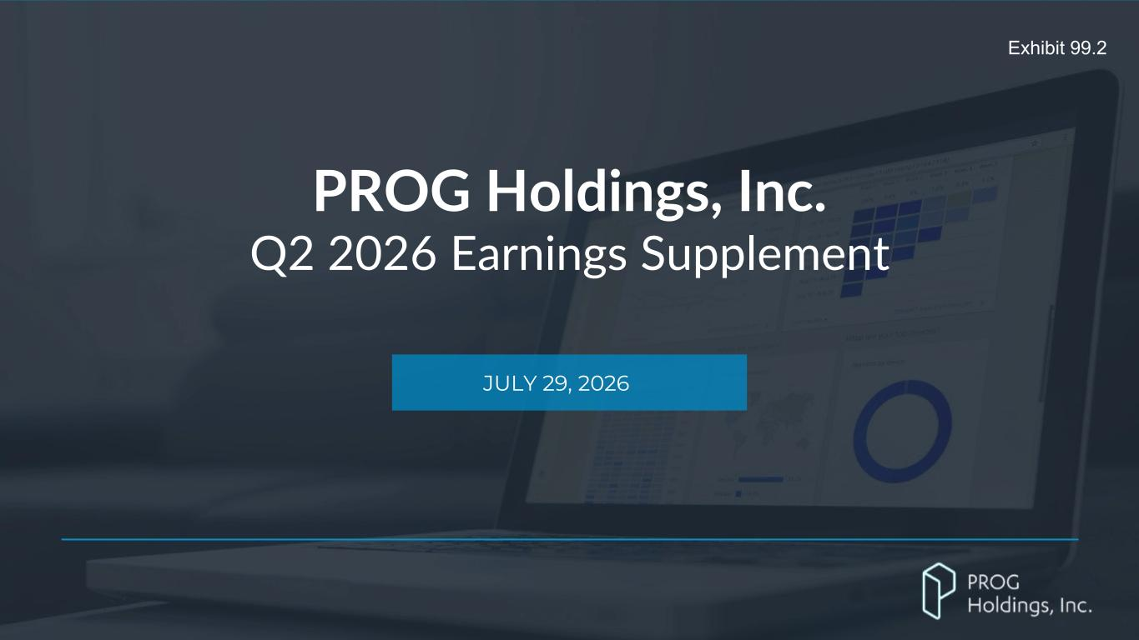

PROG Internal PROG Holdings, Inc. Q2 2026 Earnings Supplement JULY 29, 2026 Exhibit 99.2

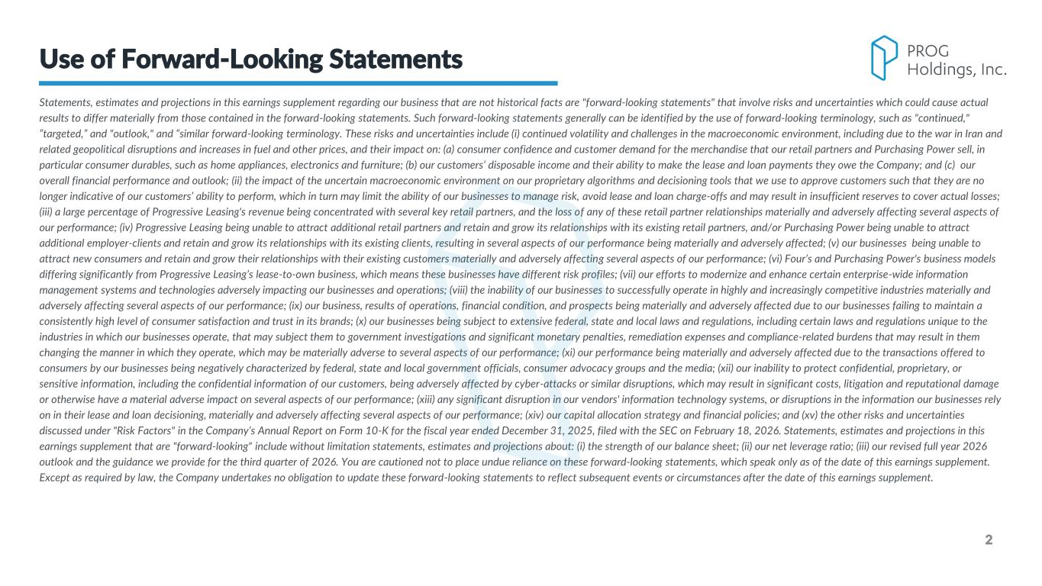
2 Statements, estimates and projections in this earnings supplement regarding our business that are not historical facts are "forward-looking statements" that involve risks and uncertainties which could cause actual results to differ materially from those contained in the forward-looking statements. Such forward-looking statements generally can be identified by the use of forward-looking terminology, such as "continued," “targeted,” and "outlook," and “similar forward-looking terminology. These risks and uncertainties include (i) continued volatility and challenges in the macroeconomic environment, including due to the war in Iran and related geopolitical disruptions and increases in fuel and other prices, and their impact on: (a) consumer confidence and customer demand for the merchandise that our retail partners and Purchasing Power sell, in particular consumer durables, such as home appliances, electronics and furniture; (b) our customers’ disposable income and their ability to make the lease and loan payments they owe the Company; and (c) our overall financial performance and outlook; (ii) the impact of the uncertain macroeconomic environment on our proprietary algorithms and decisioning tools that we use to approve customers such that they are no longer indicative of our customers’ ability to perform, which in turn may limit the ability of our businesses to manage risk, avoid lease and loan charge-offs and may result in insufficient reserves to cover actual losses; (iii) a large percentage of Progressive Leasing's revenue being concentrated with several key retail partners, and the loss of any of these retail partner relationships materially and adversely affecting several aspects of our performance; (iv) Progressive Leasing being unable to attract additional retail partners and retain and grow its relationships with its existing retail partners, and/or Purchasing Power being unable to attract additional employer-clients and retain and grow its relationships with its existing clients, resulting in several aspects of our performance being materially and adversely affected; (v) our businesses being unable to attract new consumers and retain and grow their relationships with their existing customers materially and adversely affecting several aspects of our performance; (vi) Four’s and Purchasing Power's business models differing significantly from Progressive Leasing’s lease-to-own business, which means these businesses have different risk profiles; (vii) our efforts to modernize and enhance certain enterprise-wide information management systems and technologies adversely impacting our businesses and operations; (viii) the inability of our businesses to successfully operate in highly and increasingly competitive industries materially and adversely affecting several aspects of our performance; (ix) our business, results of operations, financial condition, and prospects being materially and adversely affected due to our businesses failing to maintain a consistently high level of consumer satisfaction and trust in its brands; (x) our businesses being subject to extensive federal, state and local laws and regulations, including certain laws and regulations unique to the industries in which our businesses operate, that may subject them to government investigations and significant monetary penalties, remediation expenses and compliance-related burdens that may result in them changing the manner in which they operate, which may be materially adverse to several aspects of our performance; (xi) our performance being materially and adversely affected due to the transactions offered to consumers by our businesses being negatively characterized by federal, state and local government officials, consumer advocacy groups and the media; (xii) our inability to protect confidential, proprietary, or sensitive information, including the confidential information of our customers, being adversely affected by cyber-attacks or similar disruptions, which may result in significant costs, litigation and reputational damage or otherwise have a material adverse impact on several aspects of our performance; (xiii) any significant disruption in our vendors' information technology systems, or disruptions in the information our businesses rely on in their lease and loan decisioning, materially and adversely affecting several aspects of our performance; (xiv) our capital allocation strategy and financial policies; and (xv) the other risks and uncertainties discussed under "Risk Factors" in the Company’s Annual Report on Form 10-K for the fiscal year ended December 31, 2025, filed with the SEC on February 18, 2026. Statements, estimates and projections in this earnings supplement that are "forward-looking" include without limitation statements, estimates and projections about: (i) the strength of our balance sheet; (ii) our net leverage ratio; (iii) our revised full year 2026 outlook and the guidance we provide for the third quarter of 2026. You are cautioned not to place undue reliance on these forward-looking statements, which speak only as of the date of this earnings supplement. Except as required by law, the Company undertakes no obligation to update these forward-looking statements to reflect subsequent events or circumstances after the date of this earnings supplement. Use of Forward-Looking Statements

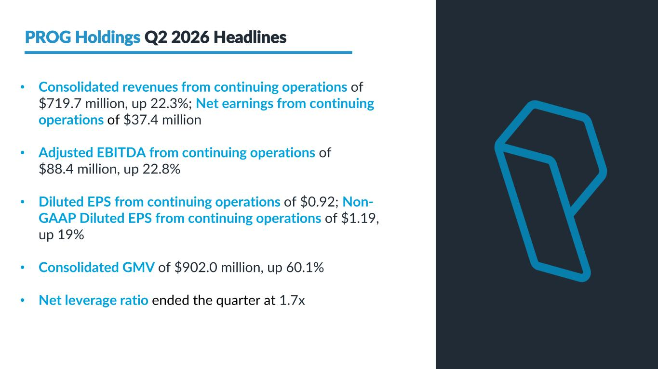
PROG Internal 3 PROG Holdings Q2 2026 Headlines • Consolidated revenues from continuing operations of $719.7 million, up 22.3%; Net earnings from continuing operations of $37.4 million • Adjusted EBITDA from continuing operations of $88.4 million, up 22.8% • Diluted EPS from continuing operations of $0.92; Non- GAAP Diluted EPS from continuing operations of $1.19, up 19% • Consolidated GMV of $902.0 million, up 60.1% • Net leverage ratio ended the quarter at 1.7x

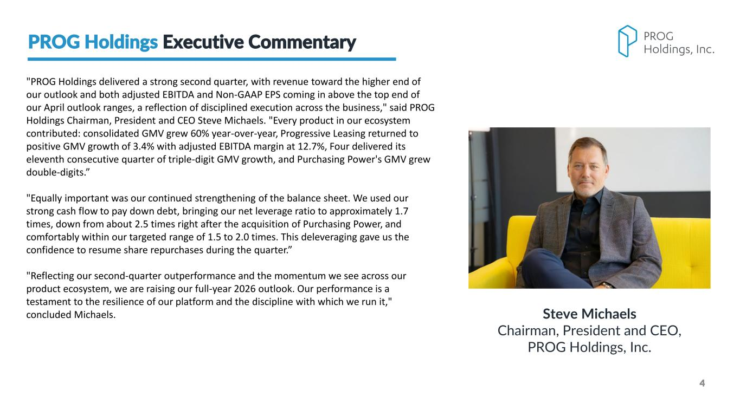
PROG Internal 4 "PROG Holdings delivered a strong second quarter, with revenue toward the higher end of our outlook and both adjusted EBITDA and Non-GAAP EPS coming in above the top end of our April outlook ranges, a reflection of disciplined execution across the business," said PROG Holdings Chairman, President and CEO Steve Michaels. "Every product in our ecosystem contributed: consolidated GMV grew 60% year-over-year, Progressive Leasing returned to positive GMV growth of 3.4% with adjusted EBITDA margin at 12.7%, Four delivered its eleventh consecutive quarter of triple-digit GMV growth, and Purchasing Power's GMV grew double-digits.” "Equally important was our continued strengthening of the balance sheet. We used our strong cash flow to pay down debt, bringing our net leverage ratio to approximately 1.7 times, down from about 2.5 times right after the acquisition of Purchasing Power, and comfortably within our targeted range of 1.5 to 2.0 times. This deleveraging gave us the confidence to resume share repurchases during the quarter.” "Reflecting our second-quarter outperformance and the momentum we see across our product ecosystem, we are raising our full-year 2026 outlook. Our performance is a testament to the resilience of our platform and the discipline with which we run it," concluded Michaels. Steve Michaels Chairman, President and CEO, PROG Holdings, Inc. PROG Holdings Executive Commentary

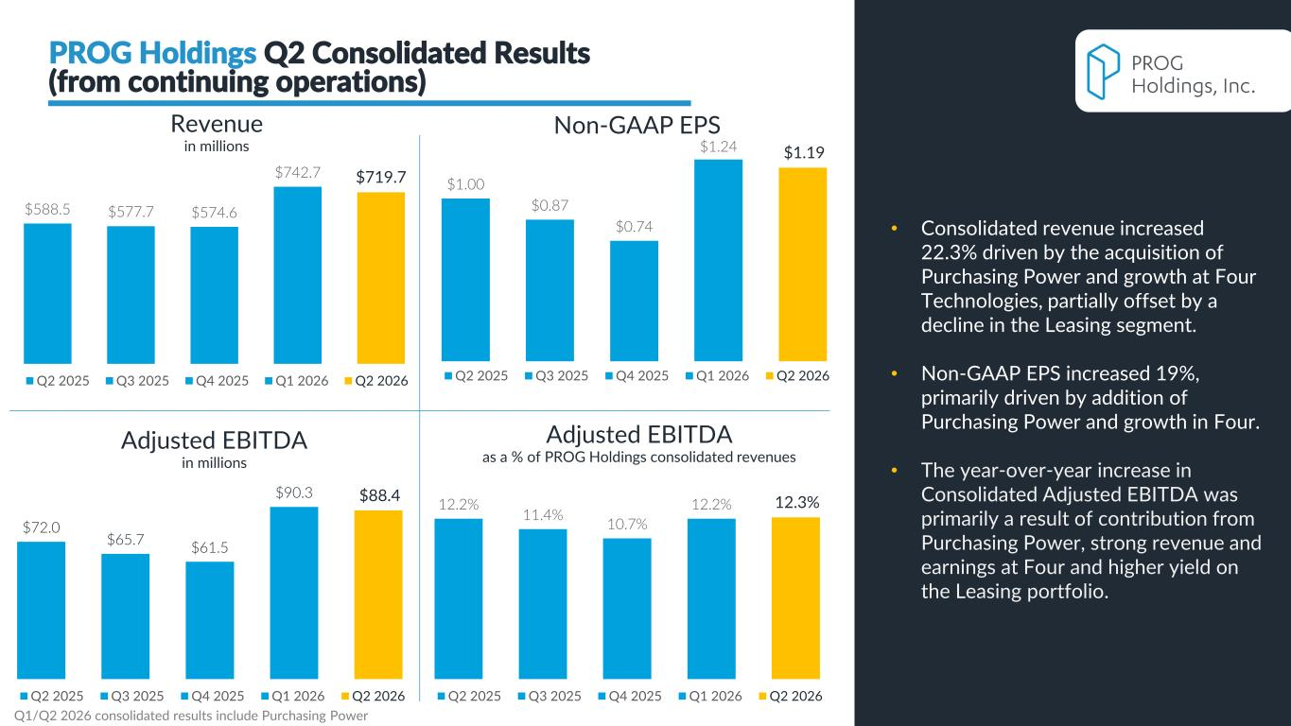
PROG Internal Adjusted EBITDA in millions 5 $588.5 $577.7 $574.6 $742.7 $719.7 Q2 2025 Q3 2025 Q4 2025 Q1 2026 Q2 2026 Non-GAAP EPSRevenue in millions 12.2% 11.4% 10.7% 12.2% 12.3% Q2 2025 Q3 2025 Q4 2025 Q1 2026 Q2 2026 Adjusted EBITDA as a % of PROG Holdings consolidated revenues PROG Holdings Q2 Consolidated Results (from continuing operations) $72.0 $65.7 $61.5 $90.3 $88.4 Q2 2025 Q3 2025 Q4 2025 Q1 2026 Q2 2026 $1.00 $0.87 $0.74 $1.24 $1.19 Q2 2025 Q3 2025 Q4 2025 Q1 2026 Q2 2026 • Consolidated revenue increased 22.3% driven by the acquisition of Purchasing Power and growth at Four Technologies, partially offset by a decline in the Leasing segment. • Non-GAAP EPS increased 19%, primarily driven by addition of Purchasing Power and growth in Four. • The year-over-year increase in Consolidated Adjusted EBITDA was primarily a result of contribution from Purchasing Power, strong revenue and earnings at Four and higher yield on the Leasing portfolio. Q1/Q2 2026 consolidated results include Purchasing Power


PROG Internal Results

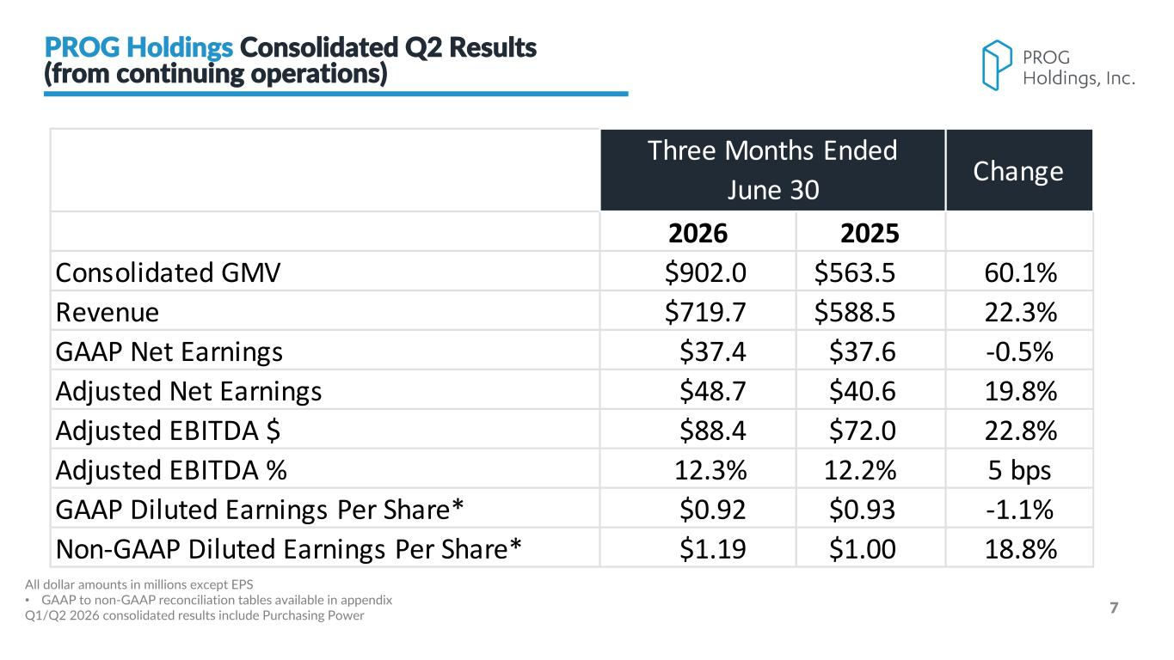
PROG Internal 7 2026 2025 Consolidated GMV $902.0 $563.5 60.1% Revenue $719.7 $588.5 22.3% GAAP Net Earnings $37.4 $37.6 -0.5% Adjusted Net Earnings $48.7 $40.6 19.8% Adjusted EBITDA $ $88.4 $72.0 22.8% Adjusted EBITDA % 12.3% 12.2% 5 bps GAAP Diluted Earnings Per Share* $0.92 $0.93 -1.1% Non-GAAP Diluted Earnings Per Share* $1.19 $1.00 18.8% Three Months Ended June 30 Change All dollar amounts in millions except EPS • GAAP to non-GAAP reconciliation tables available in appendix Q1/Q2 2026 consolidated results include Purchasing Power PROG Holdings Consolidated Q2 Results (from continuing operations)

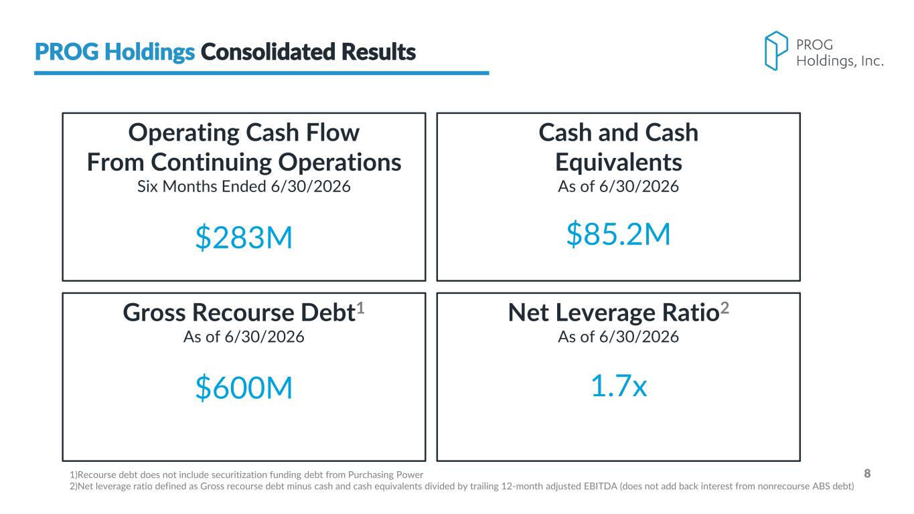
PROG Internal 8 PROG Holdings Consolidated Results Cash and Cash Equivalents As of 6/30/2026 $85.2M Gross Recourse Debt1 As of 6/30/2026 $600M Net Leverage Ratio2 As of 6/30/2026 1.7x Operating Cash Flow From Continuing Operations Six Months Ended 6/30/2026 $283M 1)Recourse debt does not include securitization funding debt from Purchasing Power 2)Net leverage ratio defined as Gross recourse debt minus cash and cash equivalents divided by trailing 12-month adjusted EBITDA (does not add back interest from nonrecourse ABS debt)

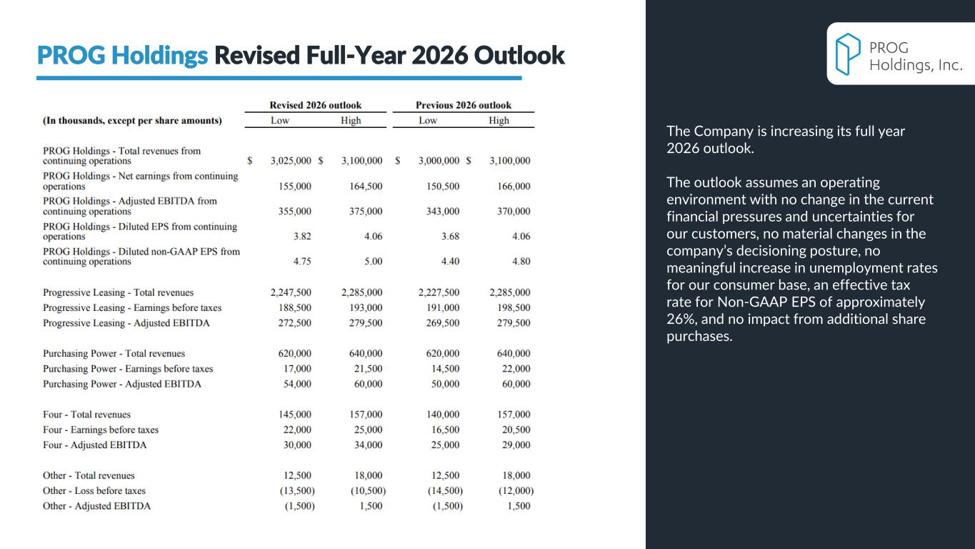
PROG Internal 9 PROG Holdings Revised Full-Year 2026 Outlook The Company is increasing its full year 2026 outlook. The outlook assumes an operating environment with no change in the current financial pressures and uncertainties for our customers, no material changes in the company’s decisioning posture, no meaningful increase in unemployment rates for our consumer base, an effective tax rate for Non-GAAP EPS of approximately 26%, and no impact from additional share purchases.

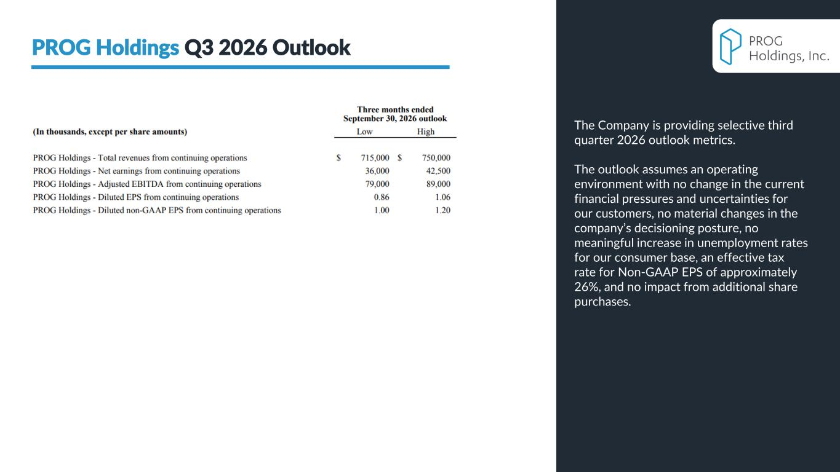
PROG Internal 10 PROG Holdings Q3 2026 Outlook The Company is providing selective third quarter 2026 outlook metrics. The outlook assumes an operating environment with no change in the current financial pressures and uncertainties for our customers, no material changes in the company’s decisioning posture, no meaningful increase in unemployment rates for our consumer base, an effective tax rate for Non-GAAP EPS of approximately 26%, and no impact from additional share purchases.


PROG Internal

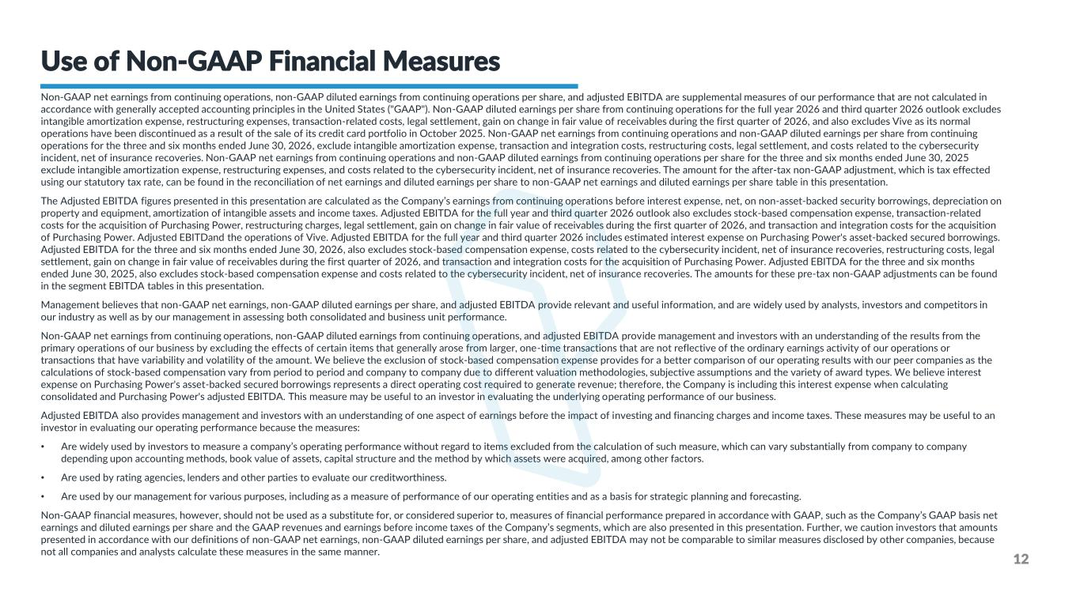
PROG Internal Non-GAAP net earnings from continuing operations, non-GAAP diluted earnings from continuing operations per share, and adjusted EBITDA are supplemental measures of our performance that are not calculated in accordance with generally accepted accounting principles in the United States ("GAAP"). Non-GAAP diluted earnings per share from continuing operations for the full year 2026 and third quarter 2026 outlook excludes intangible amortization expense, restructuring expenses, transaction-related costs, legal settlement, gain on change in fair value of receivables during the first quarter of 2026, and also excludes Vive as its normal operations have been discontinued as a result of the sale of its credit card portfolio in October 2025. Non-GAAP net earnings from continuing operations and non-GAAP diluted earnings per share from continuing operations for the three and six months ended June 30, 2026, exclude intangible amortization expense, transaction and integration costs, restructuring costs, legal settlement, and costs related to the cybersecurity incident, net of insurance recoveries. Non-GAAP net earnings from continuing operations and non-GAAP diluted earnings from continuing operations per share for the three and six months ended June 30, 2025 exclude intangible amortization expense, restructuring expenses, and costs related to the cybersecurity incident, net of insurance recoveries. The amount for the after-tax non-GAAP adjustment, which is tax effected using our statutory tax rate, can be found in the reconciliation of net earnings and diluted earnings per share to non-GAAP net earnings and diluted earnings per share table in this presentation. The Adjusted EBITDA figures presented in this presentation are calculated as the Company’s earnings from continuing operations before interest expense, net, on non-asset-backed security borrowings, depreciation on property and equipment, amortization of intangible assets and income taxes. Adjusted EBITDA for the full year and third quarter 2026 outlook also excludes stock-based compensation expense, transaction-related costs for the acquisition of Purchasing Power, restructuring charges, legal settlement, gain on change in fair value of receivables during the first quarter of 2026, and transaction and integration costs for the acquisition of Purchasing Power. Adjusted EBITDand the operations of Vive. Adjusted EBITDA for the full year and third quarter 2026 includes estimated interest expense on Purchasing Power's asset-backed secured borrowings. Adjusted EBITDA for the three and six months ended June 30, 2026, also excludes stock-based compensation expense, costs related to the cybersecurity incident, net of insurance recoveries, restructuring costs, legal settlement, gain on change in fair value of receivables during the first quarter of 2026, and transaction and integration costs for the acquisition of Purchasing Power. Adjusted EBITDA for the three and six months ended June 30, 2025, also excludes stock-based compensation expense and costs related to the cybersecurity incident, net of insurance recoveries. The amounts for these pre-tax non-GAAP adjustments can be found in the segment EBITDA tables in this presentation. Management believes that non-GAAP net earnings, non-GAAP diluted earnings per share, and adjusted EBITDA provide relevant and useful information, and are widely used by analysts, investors and competitors in our industry as well as by our management in assessing both consolidated and business unit performance. Non-GAAP net earnings from continuing operations, non-GAAP diluted earnings from continuing operations, and adjusted EBITDA provide management and investors with an understanding of the results from the primary operations of our business by excluding the effects of certain items that generally arose from larger, one-time transactions that are not reflective of the ordinary earnings activity of our operations or transactions that have variability and volatility of the amount. We believe the exclusion of stock-based compensation expense provides for a better comparison of our operating results with our peer companies as the calculations of stock-based compensation vary from period to period and company to company due to different valuation methodologies, subjective assumptions and the variety of award types. We believe interest expense on Purchasing Power's asset-backed secured borrowings represents a direct operating cost required to generate revenue; therefore, the Company is including this interest expense when calculating consolidated and Purchasing Power's adjusted EBITDA. This measure may be useful to an investor in evaluating the underlying operating performance of our business. Adjusted EBITDA also provides management and investors with an understanding of one aspect of earnings before the impact of investing and financing charges and income taxes. These measures may be useful to an investor in evaluating our operating performance because the measures: • Are widely used by investors to measure a company’s operating performance without regard to items excluded from the calculation of such measure, which can vary substantially from company to company depending upon accounting methods, book value of assets, capital structure and the method by which assets were acquired, among other factors. • Are used by rating agencies, lenders and other parties to evaluate our creditworthiness. • Are used by our management for various purposes, including as a measure of performance of our operating entities and as a basis for strategic planning and forecasting. Non-GAAP financial measures, however, should not be used as a substitute for, or considered superior to, measures of financial performance prepared in accordance with GAAP, such as the Company’s GAAP basis net earnings and diluted earnings per share and the GAAP revenues and earnings before income taxes of the Company’s segments, which are also presented in this presentation. Further, we caution investors that amounts presented in accordance with our definitions of non-GAAP net earnings, non-GAAP diluted earnings per share, and adjusted EBITDA may not be comparable to similar measures disclosed by other companies, because not all companies and analysts calculate these measures in the same manner. 12 Use of Non-GAAP Financial Measures

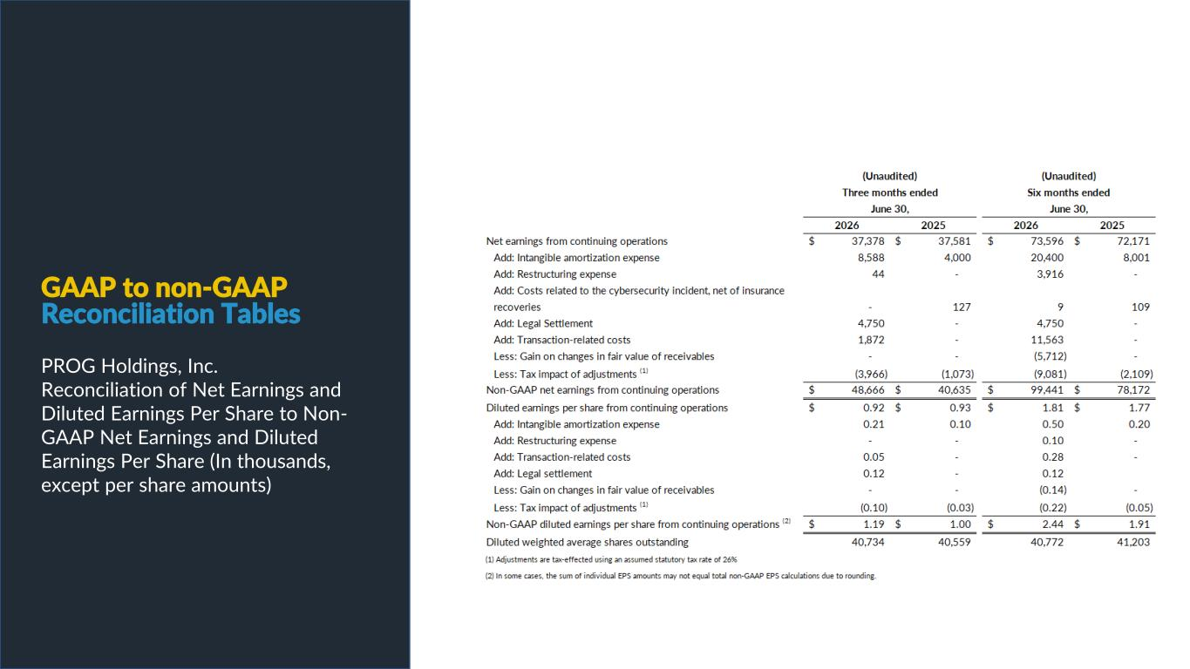
PROG Internal GAAP to non-GAAP Reconciliation Tables PROG Holdings, Inc. Reconciliation of Net Earnings and Diluted Earnings Per Share to Non- GAAP Net Earnings and Diluted Earnings Per Share (In thousands, except per share amounts)

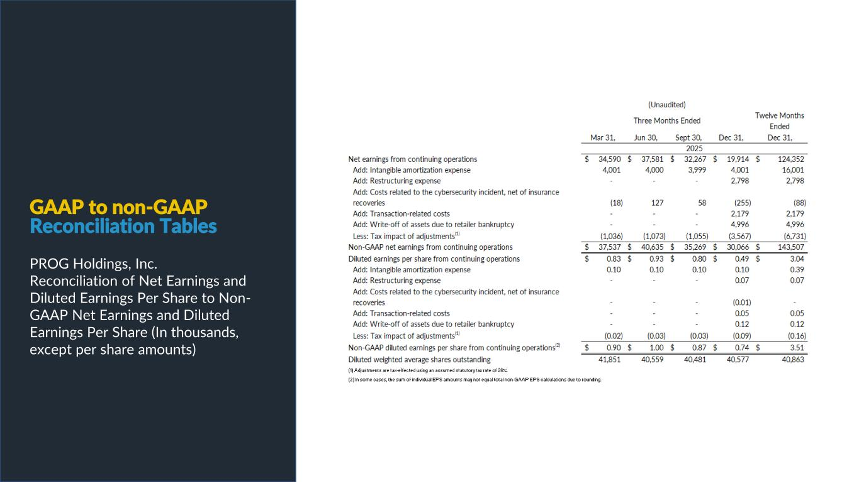
PROG Internal GAAP to non-GAAP Reconciliation Tables PROG Holdings, Inc. Reconciliation of Net Earnings and Diluted Earnings Per Share to Non- GAAP Net Earnings and Diluted Earnings Per Share (In thousands, except per share amounts)

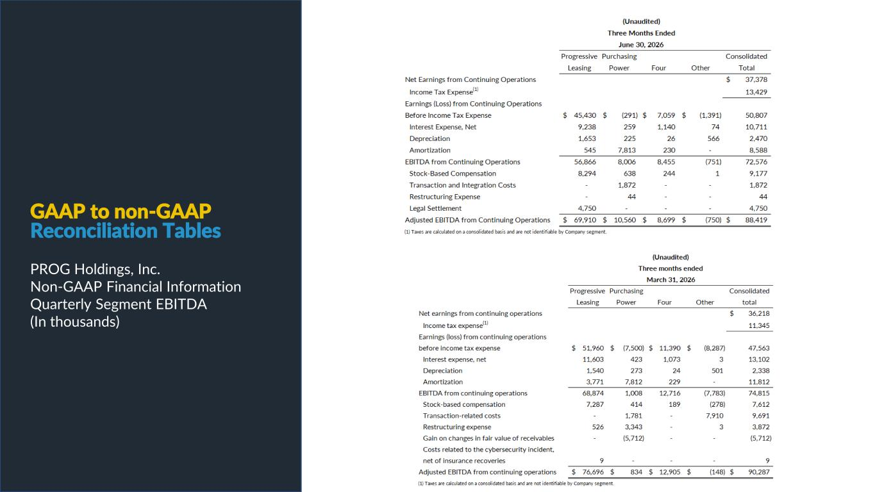
PROG Internal GAAP to non-GAAP Reconciliation Tables PROG Holdings, Inc. Non-GAAP Financial Information Quarterly Segment EBITDA (In thousands)

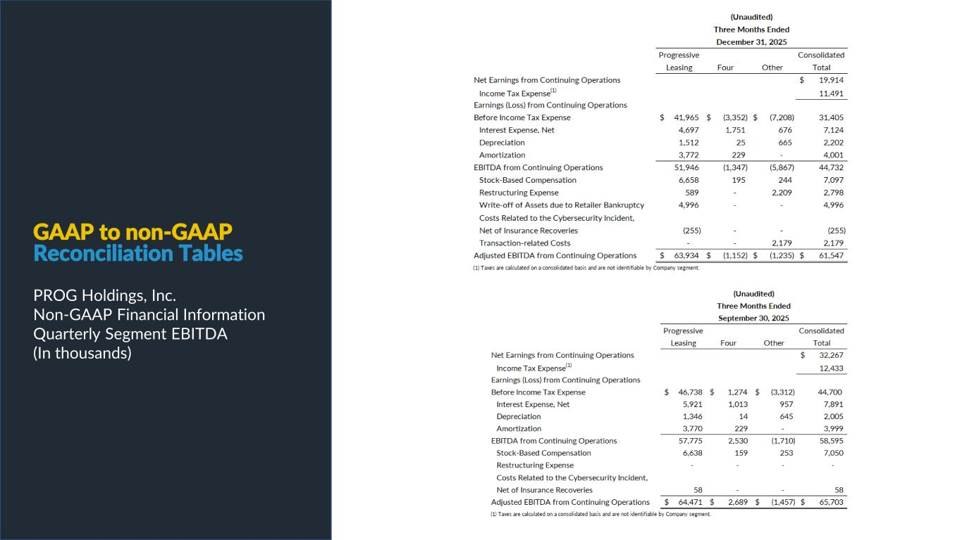
PROG Internal GAAP to non-GAAP Reconciliation Tables PROG Holdings, Inc. Non-GAAP Financial Information Quarterly Segment EBITDA (In thousands)

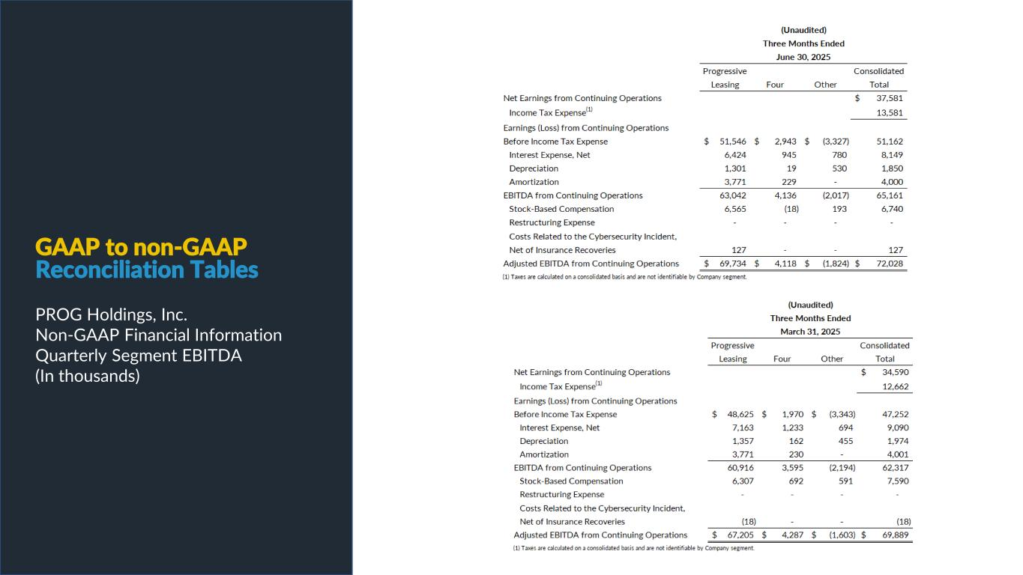
PROG Internal GAAP to non-GAAP Reconciliation Tables PROG Holdings, Inc. Non-GAAP Financial Information Quarterly Segment EBITDA (In thousands)

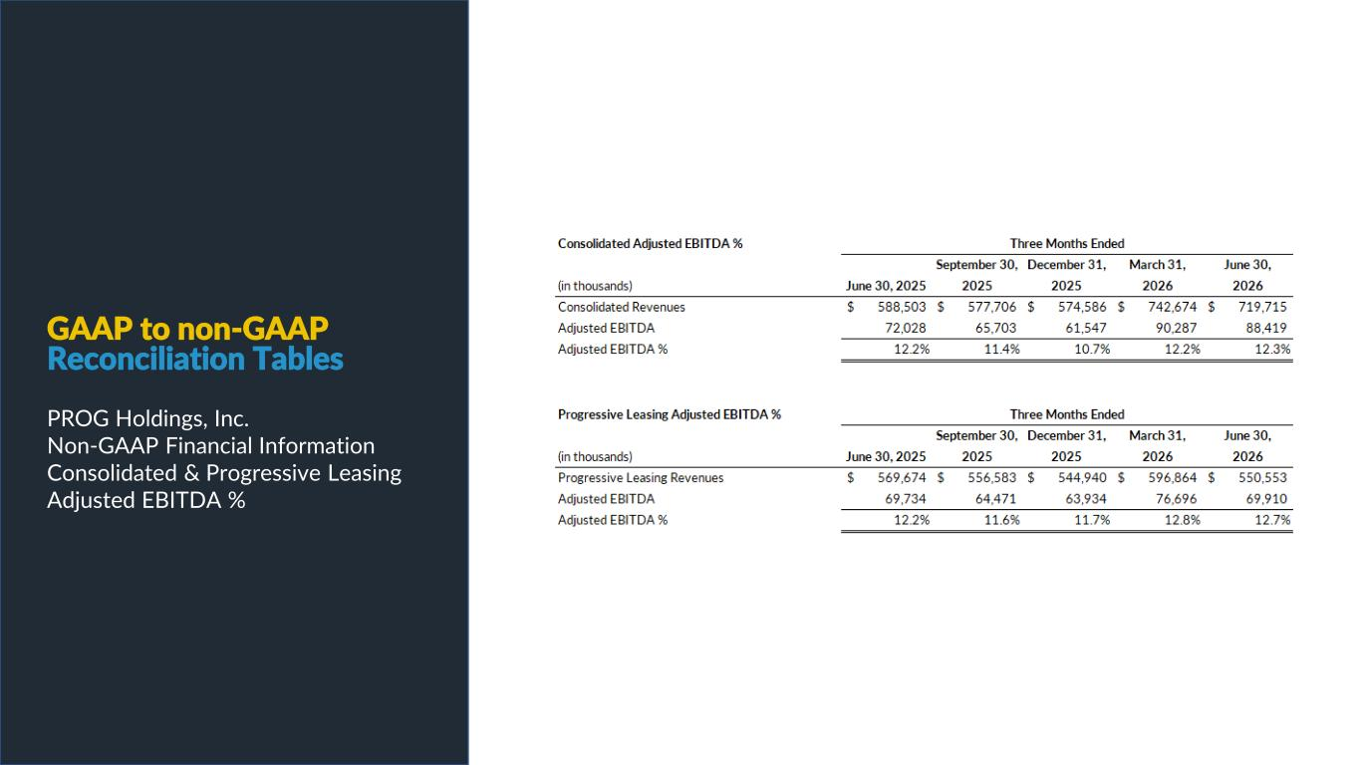
PROG Internal GAAP to non-GAAP Reconciliation Tables PROG Holdings, Inc. Non-GAAP Financial Information Consolidated & Progressive Leasing Adjusted EBITDA %

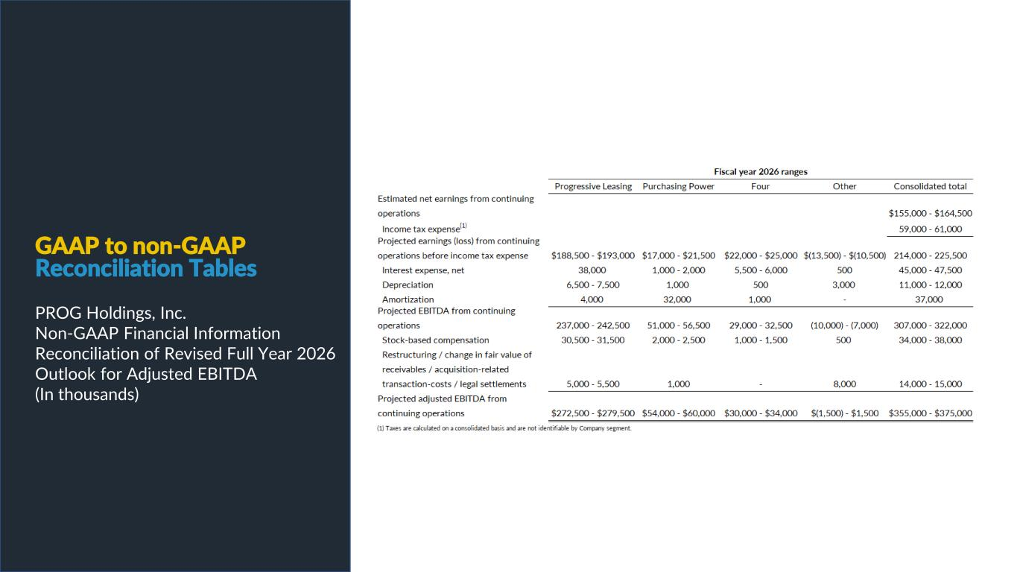
PROG Internal GAAP to non-GAAP Reconciliation Tables PROG Holdings, Inc. Non-GAAP Financial Information Reconciliation of Revised Full Year 2026 Outlook for Adjusted EBITDA (In thousands)

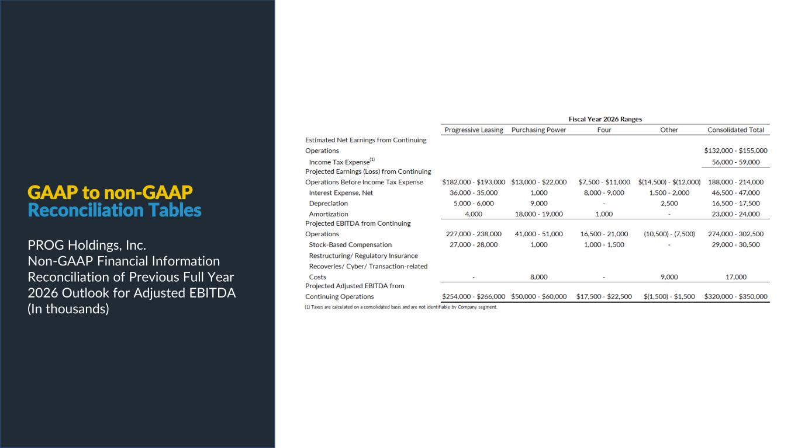
PROG Internal GAAP to non-GAAP Reconciliation Tables PROG Holdings, Inc. Non-GAAP Financial Information Reconciliation of Previous Full Year 2026 Outlook for Adjusted EBITDA (In thousands)

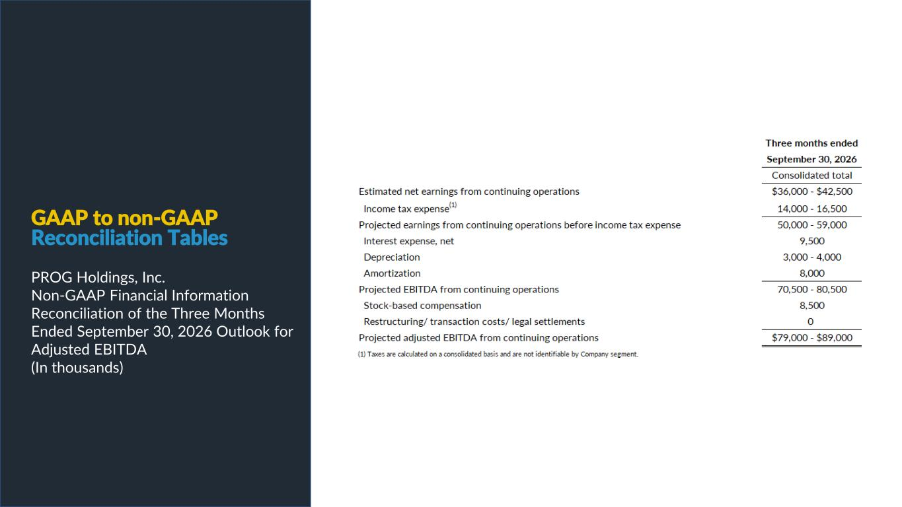
PROG Internal GAAP to non-GAAP Reconciliation Tables PROG Holdings, Inc. Non-GAAP Financial Information Reconciliation of the Three Months Ended September 30, 2026 Outlook for Adjusted EBITDA (In thousands)

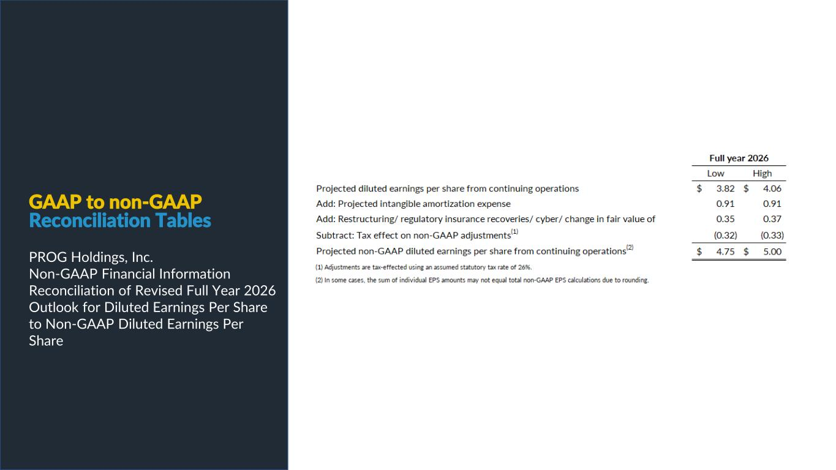
PROG Internal GAAP to non-GAAP Reconciliation Tables PROG Holdings, Inc. Non-GAAP Financial Information Reconciliation of Revised Full Year 2026 Outlook for Diluted Earnings Per Share to Non-GAAP Diluted Earnings Per Share

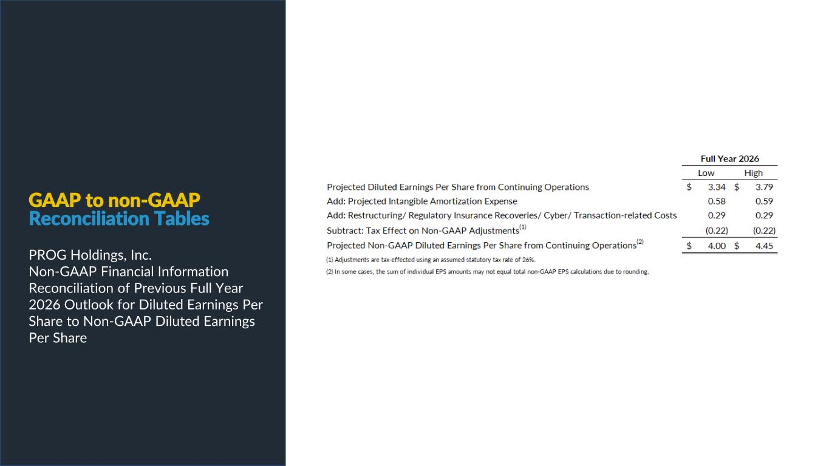
PROG Internal GAAP to non-GAAP Reconciliation Tables PROG Holdings, Inc. Non-GAAP Financial Information Reconciliation of Previous Full Year 2026 Outlook for Diluted Earnings Per Share to Non-GAAP Diluted Earnings Per Share

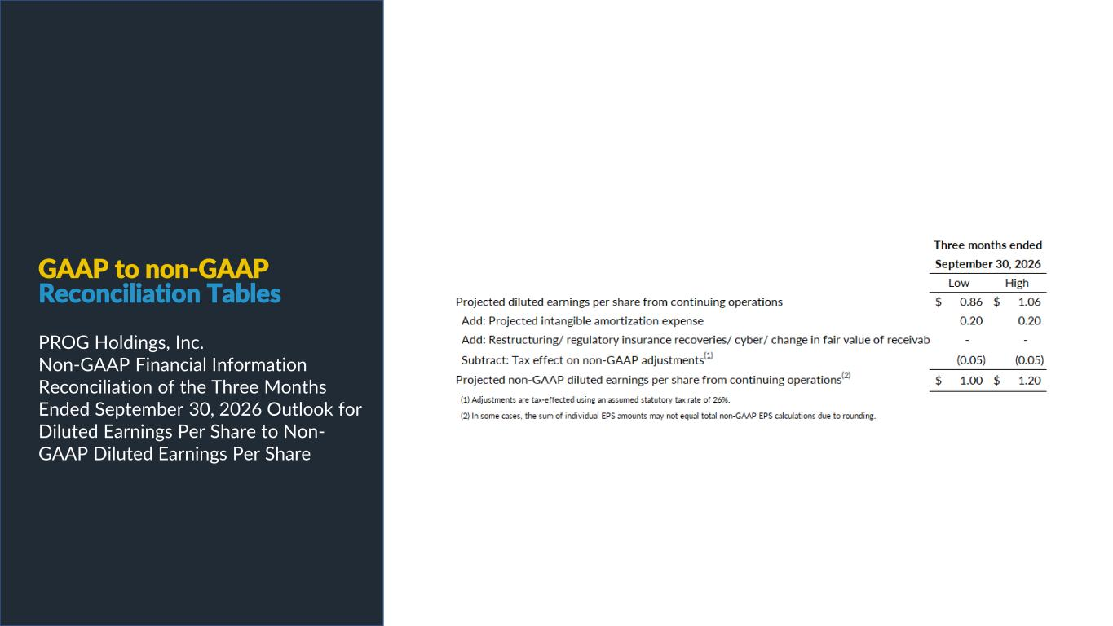
GAAP to non-GAAP Reconciliation Tables PROG Holdings, Inc. Non-GAAP Financial Information Reconciliation of the Three Months Ended September 30, 2026 Outlook for Diluted Earnings Per Share to Non- GAAP Diluted Earnings Per Share


PROG Internal

